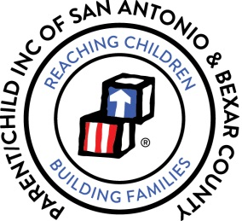
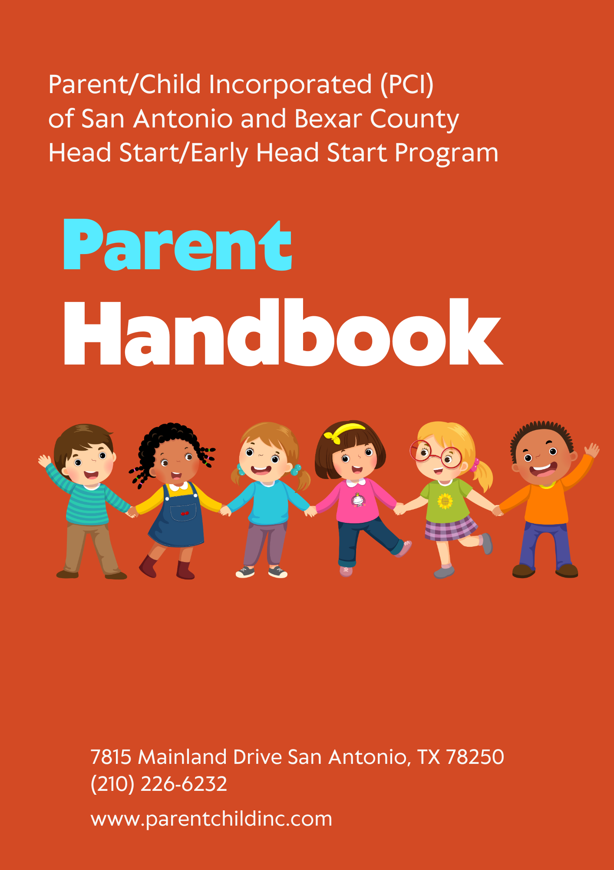

Table of Contents

Message from the CEO | Page 5
Mission Statement | Page 6
Vision Statement | Page 6
Value Statement | Page 6

I. OVERVIEW OF PROGRAM
1. Transition Tips | Pages 7-8
2. Your Child’s Routine in a Head Start Program Classroom | Page 8
3. What Can the Head Start Program Offer Your Child? | Page 8-9
4. What Can Head Start Offer Your Family? | Page 9
5. Recruitment/Eligibility/Enrollment/Attendance  - Recruitment/Eligibility  - Enrollment  - Program Withdrawal  - Attendance  - Transfers | Pages 9-11
6. Children Arrival/Departure Check | Page 11
7. PCI Head Start/Early Head Start Early Learning Centers Hours of  Operation | Page 11
8. Early Release Days | Page 12
9. Drop-Off/Pick-Up Procedures | Pages 12-13
10. Late Pick Up/After Care Fee | Page 13
11. Religious Activities in Head Start | Page 13
12. Request for Child’s Records | Pages 13-14
13. Video Surveillance | Pages 13-16

II. EDUCATION
1. Education Philosophy | Page 17
2. Curriculum | Pages 17-18
3. Daily Activity Schedule (Sample) | Page 18-19
4. Head Start Early Learning Outcome Framework from Birth to Five | Page 19
5. Central Domains | Page 19
6. Dual Language Learners and Cultural Diversity Service | Page 19
7. Multicultural Principles of Head Start Program | Page 20
8. Learning Environment | Page 20
9. Home Visits | Page 20
10. Parent/Teacher Conferences | Pages 20-21
11. PCI’s Role in Supporting Children’s Learning and Development | Page 21
12. Parent’s Role in Supporting Their Child’s Learning and Development | Page 21
13. Home Enrichment Activities | Page 21
14. End of Program Year Family & Child Celebration | Page 22
15. Redirection | Pages 22-23
II. EDUCATION CONTINUED
16. Suspension and Expulsion | Page 23
17. Clothing | Page 23
18. Rest Time | Page 23
19. Field Trips | Page 24
20. Seatbelt Safety | Page 24
21. Where’s Baby? Look Before You Lock! | Page 24
22. Pledge to Prevent Child Heatstroke in Cars | Pages 24-25
23. Early Head Start (Birth to 3 Years Old) | Page 26-27
24. Nutrition | Page 27

III. HEALTH
1. Disabilities Services | Page 27
2. Children with Special Needs | Page 27
3. Mental Health | Page 28
4. Levels of Mental Health Interventions | Page 28
5. Health Services and Requirements  - Current Physical Examinations  - Physical Examinations  - Lead Screenings  - Immunizations  - Dental Examinations  - THSteps Medical Checkup Periodicity Schedule for Infants, Children  - Recommended Immunization Schedule for Children Aged 0 to 16 | Pages 28-31
6. Daily Health Observations | Page 32
7. Medical Emergency Information | Page 32
8. Accident Reports | Page 32
9. Medication Administration | Pages 32-33
10. Tooth Brushing | Page 33

IV. NUTRITION
1. Child Nutrition Services | Page 33
2. Breastfeeding | Page 33
3. Meals | Pages 33-34

V. FAMILY & COMMUNITY PARTNERSHIP
1. Family Engagement | Page 34
2. How Can You Be An Active Partner in Head Start/Early Head Start? | Pages 34-35
3. Male Initiative | Page 35
4. In-Kind | Page 35
5. Parent Rights in the Head Start/Early Head Start Program | Page 35
6. Parent and/or Guardian Responsibilities | Pages 35-36
7. Dollar Per Child Campaign | Page 37

V. FAMILY & COMMUNITY PARTNERSHIP CONTINUED
8. Policy Council | Page 37
9. Policy Council Responsibilities | Page 37
10. Early Head Start-Child Care Partnership (EHS-CCP) | Pages 37-38

VI. PROGRAM DESIGN AND MANAGEMENT
1. Program Design & Management Introduction | Page 38
2. Career Development & Training | Page 38
3. Pre-Service & On-Going Training | Page 38
4. Parent Concerns | Page 38
5. Parent/Community Complaint Procedures | Page 39

VII. ADULT CODE OF CONDUCT HEAD START Pages 39-40
VIII. IMPORTANT POLICIES
1. Confidentiality | Page 40
2. Right of Access | Page 40
3. Attendance Policy | Page 41
4. Child Abuse Reporting Policy | Pages 41-42
5. Center Closures Due to Inclement Weather & Push Notification System | Page 42
6. PCI Parent Notification System | Pages 42-43

IX. HEAD START FREQUENTLY ASKED QUESTIONS Page 43
X. IMPORTANT PHONE NUMBERS Page 44
XI. PCI OBSERVED HOLIDAYS/BREAKS Page 45
XII. STAFF DEVELOPMENT DAY CLOSURES Page 45
XIII. CENTER DIRECTORY Page 46
XIV. ORGANIZATIONAL CHART Page 47
XV. NOTES PAGE Page 48
XVI. CHILD AND ADULT CARE FOOD PROGRAM Pages 49-51
(CACFP) INFORMATION AND PARENT NOTIFICATIONS


Message from Dr. Sharon Small, CEO

Dear Parents and Families,
Welcome to Parent/Child Incorporated (PCI) where we are “Growing San Antonio’s Tomorrow…Today…Together!” We are excited to have you and your child as part of our community. Our goal is to provide your child with a strong foundation for lifelong learning, and we believe that family involvement is key to their success.
At PCI, we are committed to creating a nurturing, safe, and inclusive environment where your child can explore, grow, and develop. We offer a comprehensive program that supports your child's academic, social, emotional, and physical development. Together, we can help your child build the skills and confidence they need to succeed in school and beyond.
We recognize that parents and caregivers are the child's first and most important teachers. That’s why we value the partnership between families and our staff. Throughout the year, we encourage you to actively engage in your child's learning experience by attending meetings, participating in activities, and sharing your thoughts and ideas.
In this handbook, you will find important information about our program, policies, and resources. We hope it will answer any questions you have and serve as a helpful guide as you navigate your journey with our program.
We are here to support you and your family. If you ever have questions, concerns, or suggestions, please don’t hesitate to reach out. Our team is here to help you every step of the way.
Thank you for entrusting us with your child's care and education. We look forward to a successful and rewarding year together!

Sincerely,

Dr. Sharon M. Small
Chief Executive Officer, HS/EHS Director




The mission of Parent/Child Incorporated is to provide high-quality early childhood developmental and educational services in order to empower our children and their families to become responsible citizens who value education and community.

Our vision is to provide the best quality child development program for all eligible children using the Head Start / Early Head Start Model which enables families, children, and staff to be empowered by creating a caring, safe and healthy environment that encourages learning and wellness.
Value Statement
We believe that in order to deliver services that change lives we must remain constantly focused on the following values:
- Excellence: setting levels of performance that go beyond the performance standards, that constantly challenge every employee in the agency to step up to the next level.
- Teamwork: the needs our families demand that staff work together across disciplines and cultural differences.
- Respect: we will nurture the self-esteem and dignity of the Head Start/Early Head Start children and parents.
- Diversity: we must not only respect differences but also value them for their power to create a stronger and more effective program.
- Integrity: creates an atmosphere of trust where people can expect to be treated fairly.
- Courage: the ability to embrace change, to step out of our comfort zones and to grow both personally and professionally.
We are family!
We facilitate quality, comprehensive services for families.
We advocate, motivate, and empower people to their fullest potential in becoming contributors and providers for the community.

- OVERVIEW OF PROGRAM

Transition Tips – Head Start
Is your child starting preschool? During transitions, children often need a little extra time, attention and support from their parents. School transitions also signal a new stage of family life for everyone.
Children may feel...
- Sadness at the loss of the old center, friends, neighborhood (and if a preschooler or kindergartner, separation from parents)
- Anxiety about the unknown
- Fear of not making friends, being accepted.
- Apprehension about their ability to do the work or master the logistics involved (getting lost, getting lunch, learning the rules, finding the bathrooms, etc.).
Parents may feel...
- Sadness about their child growing up and moving on to the next stage
- Anxiety about whether the new school and/or teacher are the best for their child.
- Uncertainty about what their own role should be in the new setting and how the new school views parent involvement.
- Awareness that their child's growing up is linked to a new stage of life for parents too, and that family life will change.
Making a smooth transition….
- If the school has scheduled an open house, orientation, welcome day or other opportunity for parents and/or children to get acquainted, make a special effort to attend.
- Take the time to talk. Ask your child what he would like to know about the new school. Write down the questions and find out the answers.
- Take the time to visit the school. You may want to call ahead to get an appointment or get permission for you and your child to take a self-tour of the building. Talk about what will happen during a typical day. Go through the schedule with your child.
Transition In/Out Early Head Start
Transition Into the EHS Program - The Education Center Coordinator, Family Service Worker, and Center staff ensures children and parents have a smooth transition in delivery of services as the children move in and out of the PCI Early Head Start and Head Start Programs. We encourage families to be involved in their children's learning and development and to support the lifelong success of their child. When a child is transitioning into the Early Head Start program, the parent is given an orientation of the program requirements. Parents are invited to spend the day at one of the Early Head Start sites to observe what a typical day entail. A briefing conference is held with Parent, Teacher, Family Service Worker and Education Center Coordinator. Parents are provided with information on how to access the PCI Website to view information about the agency.
Transitioning out of Head Start Program
Leaving preschool to enter the school district educational system represents a significant transition for every parent and child. The environment will be new, the challenges will be different, and new relationships will develop. At Parent/Child Incorporated, we play a crucial role in helping with the transition process to help families achieve long-term educational success.
Head Start children transitioning to Public/Charter School Kindergarten will be eligible to participate in the Head Start transition ceremony. The Transition ceremonies will take place on the last day of school.
Transitioning Out of EHS Program - Six months prior to the child’s third birthday, the Education Center Coordinator and Family Service Worker meets with the parents to develop a transition plan to have the child enrolled into either a Head Start Program (if slots are available) or other educational program that has available slots. A checklist with specific steps for transitioning is reviewed with the parent and used as a guide for the program to ensure adherence to the process. The Family Service Worker assists parents in completing the application process for transitioning their child into the Head Start Program or a program of their choice. Parents are encouraged to take the child to visit the new center thirty days prior to exiting the EHS program. In order to provide continuity of care, the Family Service Worker will serve as the contact between the parent and the Education Center Coordinator of the new Head Start placement.

Your Child’s Routine in a Head Start Program Classroom - Classroom time includes many different activities. Some teachers begin the day by asking the children to sit in a circle. This encourages the children to talk about an idea or experience they want to share with others. During learning center time, the teacher plans and sets the stage for learning. The children may choose between art, playing with blocks or table toys, science activities, dancing to music, looking at books, or pretend housekeeping and various other learning centers. Children can choose activities if they prefer another challenge. Each day, they have time to work in a small group with other children and to play outdoors on safe playground equipment.

Nutritious meals are served for breakfast, lunch and snacks. Children are encouraged to brush their teeth at least once during the day. All the children are taught to wash their hands before meals and are encouraged to develop good personal and healthy habits. Personal hygiene habits are taught in the classroom and help your child to develop good hygiene skills for school and lower the risk of illnesses.
What Can the Head Start Program Offer Your Child? The program provides children with activities that help them grow mentally, socially, emotionally, and physically. The Head Start staff recognize that, as parents, you are the first and most important teacher for your child. They will welcome your involvement in Head Start activities and will work as a partner with you to help your child’s progress.
Head Start staff members offer your childcare, acceptance, and understanding, the opportunity to learn and to experience success. Head Start children learn to socialize with others, solve problems, improve their listening and speaking skills and have other experiences, which help them become self-confident.
The children spend time in stimulating settings where they form good habits and enjoy playing with age-appropriate learning toys and working on tasks with classmates. Your child will leave Head Start more prepared for kindergarten, excited about learning and ready to succeed.
Your Head Start/Early Head Start child will also be screened and examined by skilled professionals for health problems. Professionals will arrange vision and hearing tests and needed immunizations. Head Start offers nutrition assessment and dental referral and follow-up services. Disabilities and Mental Health services are available for children and families with special needs.
What Can Head Start Offer Your Family? Parent/Child Incorporated and families will work together as equal partners to build strong relationships that support information sharing. The Family Service Worker will communicate with the parent regularly and work together to identify and achieve goals and aspirations. They will communicate in the family’s preferred language and the information discussed will be kept confidential. Family Service Workers refer families to appropriate agencies that aid in obtaining medical, social services, or employment opportunities. They know the community and will follow up to ensure services meet the family’s expectations.
Head Start/Early Head Start offers a sense of belonging, other support services, and a chance to be involved in activities to help your whole family. Parents and family members can take part in training on many subjects, such as job training, health and nutrition, and how to gain access to free resources in your own community. Some parents learn the English language, while others learn to read. Head Start/Early Head Start also offers assistance to parents interested in obtaining a high school General Equivalency Diploma (GED) or other adult education opportunities.
You can become a Head Start volunteer and learn more about child development. This experience may later qualify you for training which can help you find employment in the childcare field. You can also have a voice in the Head Start program by serving on various committees.
Recruitment/Eligibility/Enrollment/Attendance
Recruitment/Eligibility
Head Start/Early Head Start maintains a yearly recruitment process for pregnant women and children ages 6 weeks through 4 years. A total of 10% funded slots will be set aside for children with special needs. Family Service Workers are available to take applications at the PCI Head Start/Early Head Start Learning Centers. For the information about the center’s location, call the PCI Headquarters at (210) 226-6232. You may also link to the PCI Website at www.parentchildinc.com to enter eligibility information for the waitlist placement. Eligibility consists of age and family annual income. Early Head Start provides services to pregnant women and infants and toddlers ages 6 weeks to 35 months. Head Start children are eligible on their 3rd birthday. Parents must provide documents proving the family’s annual income. The required income documents are Tax Form 1040, W2, check stubs, school/training documents, SSI, TANF, Foster Care, child support and signed declaration.
Enrollment
Parent/Child Incorporated Head Start/Early Head Start Program are funded by the Administration for Child and Families, Department of Health and Human Services. PCI currently serves a total of 1,062 slots (646 Head Start 3- & 4-year-old is, 128 Early Head Start infants/toddlers and pregnant women, 168 EHS Expansion infants/toddlers, 120 EHS Partnerships infants/toddlers) throughout San Antonio and Bexar County. Applications are taken continuously throughout the year to obtain as many applications as possible to help assist in gaining a number of applications that are greater than our enrollment opportunities. Parent/Child Incorporated will select the neediest children without regard of race, gender, disability, or creed in accordance with Head Start regulations and the Head Start Act. A systematic selection process is implemented to review new applications and determine selection of eligible children for enrollment using child’s age, disabilities, and family’s needs/situations as outlined in the Selection Point Criteria. Children are enrolled into PCI (Head Start/Early Head Start) from Priority waiting lists which rank children according to points assigned from the established selection criteria. The ChildPlus data system will automatically prioritize according to criteria points. The program is required to always serve those children that are most in need of services. The parents of children who are not selected for immediate enrollment are notified of their child’s wait list status. Parents are notified of policy changes through our parent meetings and website.
Program Withdrawal
Parents are responsible for understanding and abiding by all PCI regulations. Termination of services (child’s withdrawal) may result should:
- A parent/guardian provides false information or withholds information regarding:
- Child’s age
- Family income
- Employment/training/school information
- Residency (must live in the service area for PCI Head Start/Early Head Start.) Please consult with the Education Center Coordinator for identification of the Service Area.
- Child’s continuous poor attendance (see Attendance section)
B. A violation of the Agency’s Zero Tolerance Policy with regards to Acts of Threats of Violence.

Attendance

Children’s daily attendance is important to their learning success and Parent/Child Incorporated’s continued Federal Government funding. Good attendance allows your child to experience daily learning activities and prepares your child for public school. Through consistent attendance, children and families are able to make maximum use of Head Start services; children learn the importance and value of being in school; and children develop responsibility early. Because it is disruptive for classes to have latecomers, children are expected to arrive on time. This allows your child time to ease into the classroom routine. Repeated tardiness may result in a need to develop an attendance plan of action. Regular attendance is required. Therefore, PCI’s expectation and goal are to maintain a 96% Average Daily Attendance (ADA) for each child enrolled.

You must call the Education Center Coordinator or Family Service Worker if your child will be absent or late before the class begins and state the reason your child will be unable to attend. Two consecutive unexcused absences or a pattern of several absences may result in a need to develop an attendance plan with you and your family.

Staff will support you through this process but failure to abide by this plan may result in your having your child placed on the waiting list. If possible, please plan to schedule doctor, dentist, housing, and all other appointments on a non-school day or other than school hours.
Transfers - PCI has a procedure in place to transfer a child from one center to another. A Transfer Request Form must be completed and signed by the Education Center Coordinator, Family Service Worker and parent/guardian. The parent/guardian will have to submit proof of new residency (CPS or water bill, etc.). The ERSEA/Family Community Specialist will review and approve or disapprove transfer. The child may be admitted into another center or placed on the wait list at the requested center. Admission to another center is dependent on whether there is a vacancy at the requested center.

It is very important that the parents/guardians provide PCI with current information at all times. It is the parents’/guardians’ responsibility to inform the Center staff of any change of address, telephone number, emergency telephone number, work/training status, family size, etc. Information will be requested on a quarterly basis to update families’ status.

Children Arrival Departure Check
Drop Off:
- Parents will bring their children into the center.
- Staff will check in children.
- Staff will conduct PCI’s Arrival/Departure Check for each child, every day.
- Note: Any employee or child who has any of the following new or worsening signs or symptoms of COVID-19 will not be allowed to attend:
    - Cough
    - Shortness of breath or difficulty breathing
    - Chills - Repeated shaking with chills
    - Muscle pain
    - Headache
    - Sore throat
    - Loss of taste or smell
    - Diarrhea
Pick Up:
- Parents will pick up their child in the center and the Arrival/Departure Check will be conducted.

PCI Head Start/Early Head Start Early Learning Centers Hours of Operation
Center Operation Hours equal to 7:15 hours per day for Head Start and 8:00 hours per day for Early Head Start.

Head Start Early Learning Centers – Monday to Friday, 7:30 am to 2:45 pm. Ages 3 years to 4 years old.

Early Head Start/EHS Expansion Early Learning Centers – Monday to Friday, 8:00 am to 4:00 pm (exception Southwest, 8:00 am to 4:45 pm) Ages 6 weeks to 35 months and pregnant women.

Head Start Staff hours – 7:15 am – 3:15 pm
Early Head Start/EHS Expansion Staff hours – 7:45 am – 3:45 pm
Extended Hours – 7:30 a.m. – 6:00 p.m. (for those who qualify)
Head Start Services – August – June
Early Head Start Services – August – August
Note: If a child has a pattern of excessive absences or if parent picks up child consistently late, the Education Center Coordinator, Family Service Worker, and Head Start /EHS Operations Coordinator will assist the parent in developing a plan to improve individual attendance. The plan will be used to resolve the problems preventing regular attendance and to support the parent in complying with the pick-up/drop off schedule. It is imperative parents abide by the set operation hours and attendance policy. Failure to comply may cause a child to be dropped from the program.
If your child is unable to come to the center or you will be late in getting your child to his/her classroom, please call the center before or by 7:30 a.m.

Early Release Days
Children are released from the center at 12:00 p.m. noon to allow for planning, collaboration and professional development time for teachers. These days may also be used for discussion with you about the progress of your child. Please make the necessary arrangements for the pick-up and care of your child/children after 12:00 p.m. noon on designated Early Release Days.

Drop-Off/Pick-Up Procedures
The procedures for parents to ensure the safety and well-being of each child in the Head Start program are as listed:

- An adult (a person 18 years or older), must accompany and legibly "sign in" the child when dropping off the child in the morning. At pick-up time, an adult must "sign-out" the child. Parents/Adults will be asked to show their picture ID at time of drop off and pick up.
- Parent/Guardian is to be dressed appropriately when dropping off/picking up children at centers.
3. If you are running late, you must call the Education Center Coordinator (ECC) or Family Service Worker to notify him/her of your approximate arrival time. This will assist the teacher to determine if a breakfast and/or lunch is ordered for your child.
4. No Registered Sex Offenders may pick up or drop off children.
5. No cell phone use is allowed in the PCI centers or classrooms.

Drop-off and Pick-up Procedures by Siblings or Other Persons Not on the Emergency List

Purpose
The purpose of the Drop-off and Pick-up Procedure by siblings or other persons not on the emergency list is to notify all concerned parties of pertinent information required regarding the arrangement between the parent and Parent/Child Incorporated.

Identification
- When the ECC is notified that a parent is in need of having a sibling or other adult not on the emergency list drop-off and/or pick-up their PCI child, the following should take place:
  - Let parents know that they must place in writing what their request is, the reason for the request and the person who will be responsible for dropping off and picking up the PCI child.
  - Letter must include that parent is “taking full and total responsibility for the child’s care and release PCI from any liability in conjunction with this arrangement.”
  - A copy of the person’s (sibling’s or other adult’s) ID must be presented when dropping off and picking up the PCI child
  - ECC must make a copy of the ID and keep it on file with the letter from the parent or guardian.
- A copy of the letter must be sent via email to the Chief Executive Officer for approval.
- Upon approval, the center will be notified, and all of the above procedures must take place.
- Staff will never release a child to anyone other than the person listed in the letter and show proper ID.
Staff will counsel parents about the pick-up policy (parent orientation). Parents will notify staff immediately of any changes in authorization for pick-up, emergency contact numbers, and personal information (phone numbers, address, etc.).
How do employees verify the identity of a parent or a person a parent has designated to pick up the child?
Before releasing a child to anyone, that person must be on the authorized pick up and show an official picture ID, such as a driver’s license. If the parent sends someone to pick up the child who is not on the authorized pick-up list, the person in charge shall call the parent to verify that the parent has given permission for that person to pick up the child. The person in charge shall then view an official ID before releasing the child.
For unforeseen circumstances, parents will call staff to inform them that they will be late and should indicate an anticipated arrival time to get to the center. If parents do not call and/or designated contact persons are not available to pick up child one (1) hour after the specified time, the San Antonio Police Department will be called, and the child will be temporarily placed in the custody of TDFPS.

Late Pick-Up/After Care Fee
Head Start regulations preclude the charging of fees to parents for Head Start services. However, if a program incurs expenses to compensate employees for the caring of a child after the Head Start program has ended, parents may be charged a reasonable fee for “after care.” There is no extended care provided beyond the closing time for your child’s center. A minimal fee for children being picked up after your child’s center has closed will be assessed.

Religious Activities in Head Start (45 CFR 87.1)
Organizations that receive direct financial assistance from the Department of Health and Human Services, including the Office of Head Start, “may not engage in inherently religious activities, such as worship, religious instructions, or proselytization, as part of the program or services funded with direct financial assistance from the Department.”
Request for Child’s Records
Consent for Release of Child/Family Information Form, which can be obtained from the Family Service Worker, will be filled out by the parent/legal guardian and submitted to the Head Start/Early Head Start/Operations Coordinator for review before submission to the Child Executive Officer/HS/EHS Director for final approval. Ten (10) days must be given for processing the request.
Video Surveillance
Security for Parent/Child Incorporated (PCI) Early Learning Centers is an essential function to ensure the safety of children, families, and staff while on PCI premises.
Parent/Child Incorporated facilities use video camera surveillance at the main entries, classrooms, hallways, parking lots, and playgrounds. All recordings are confidential for the safety of all children; therefore, there is limited access to the videos and are used for internal purposes only to include as a teaching and learning tool for staff.
Why Parents Have Limited Access to Classroom Cameras at Childcare facilities
Many daycare centers use security cameras to monitor classrooms, ensuring the safety of children and staff. However, parents are often only given direct access to these live feeds. While this may raise concerns, there are several important reasons behind this policy:
1. Privacy and Security
Daycares must protect the privacy of all children in their care. Live camera access could expose children to unauthorized viewing, even if unintentionally. Federal and state privacy laws, such as the Children’s Online Privacy Protection Act (COPPA), impose strict guidelines on sharing video footage of minors.
2. Legal and Ethical Considerations
Providing access to classroom cameras could lead to potential legal issues. If multiple parents are watching, concerns over unauthorized recording, distribution of footage, or even misuse of content could arise. Additionally, staff members also have privacy rights, and constant external surveillance may create a stressful work environment.
3. Safety from Cybersecurity Threats
Live-streaming cameras accessible by multiple users increase the risk of hacking or unauthorized access. Even with strong cybersecurity measures, allowing remote access to cameras introduces vulnerabilities that could be exploited.
Below are Parent Rights forms, in English and Spanish, required to be provided to Parents by the Texas Department of Health and Human Services.
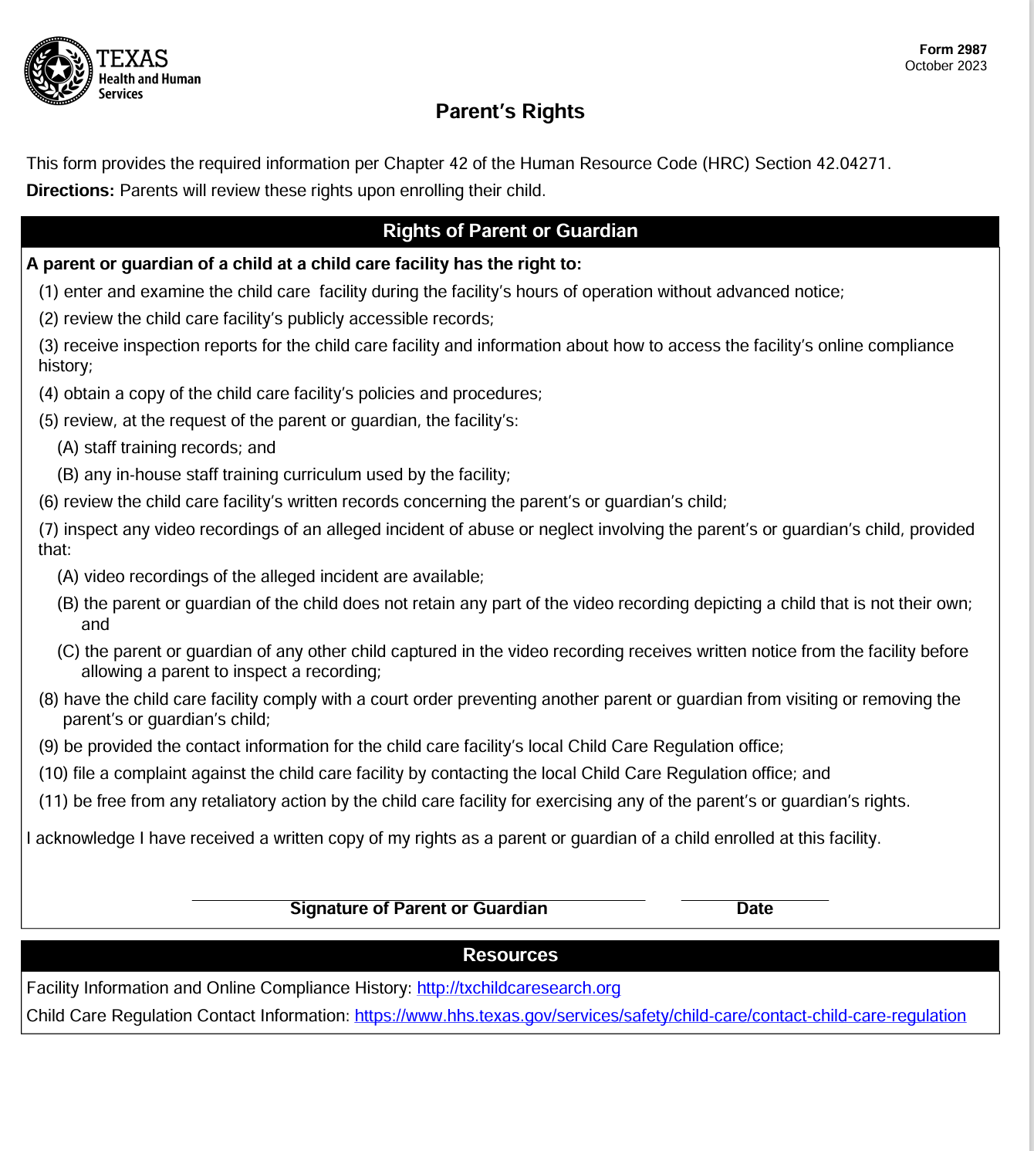
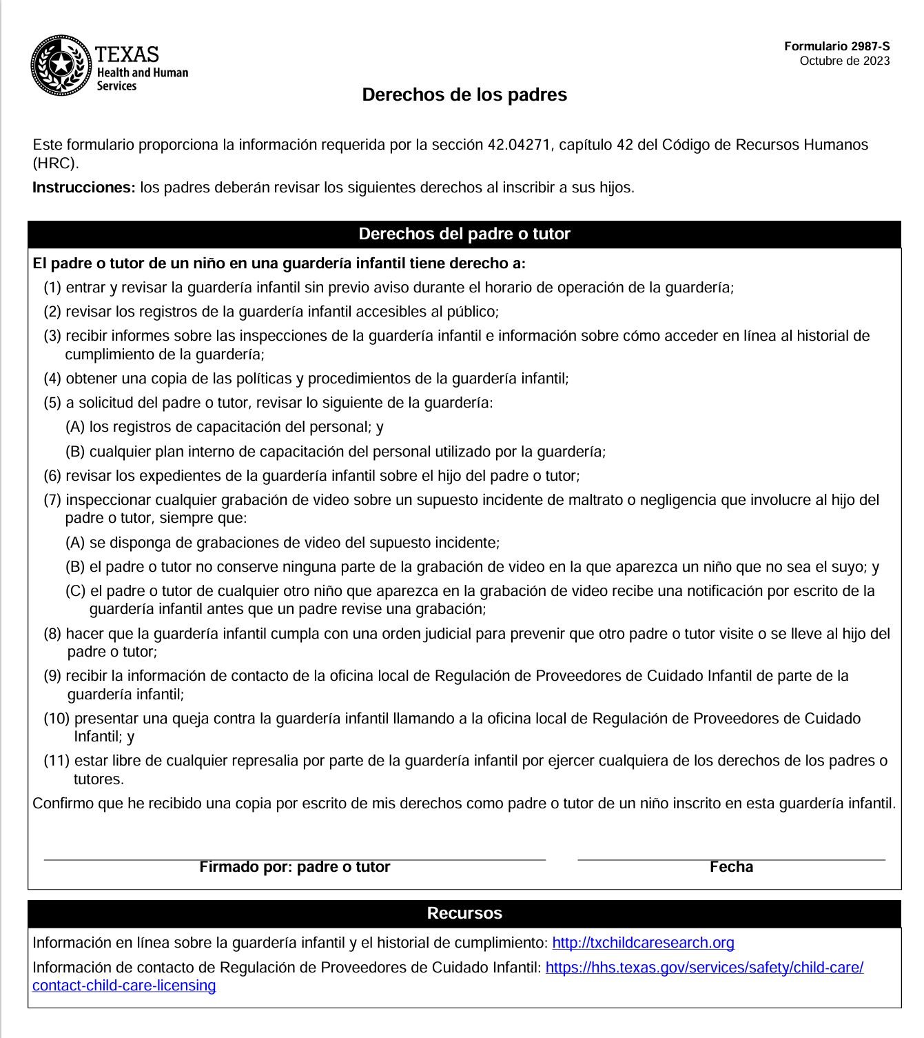

- EDUCATION
Education Philosophy
The PCI Head Start/Early Head Start Program believes that the lives of young children and their families can be enriched and strengthened through quality educational programs. Head Start provides a safe and nurturing learning environment that supports young children’s development and learning. Head Start's educational program is designed to meet each child's individual needs within the context of his/her family culture and community. Understanding that the needs of children and families vary considerably from community to community, programs must take into account community resources and the capabilities and expertise of local staff, in order to serve family needs most effectively.

Curriculum
The PCI Head Start and Early Head Start Program implements a research-based curriculum that supports children’s school readiness and is aligned with the Head Start Program Performance Standards. It is based on sound child development principles about how children grow and learn.
The curriculum goals are aligned with the Head Start requirements for curriculum.
HSPS 1302.32 (a) (1) (i) (ii) (iii) (2) (b); 1302.34 (a)(b)(1)(4); 1302.31 (d)
- Goals for children’s development and learning as outlined with the Head Start Early Learning Framework.
- Experiences through which they will achieve these goals based on developmental progressions and how they learn.
- What staff and parents can do to help children achieve these goals is by providing feedback on the curriculum and materials used daily.
- Materials needed to support the implementation of the curriculum, support children's interest, development, and learning.

PCI utilizes The Creative Curriculum for Infants and Toddlers and The Creative Curriculum for Preschool. The curriculum is implemented with attention to the needs, interests, and developmental levels of each child and supports all areas of development and learning. Learning activities and experiences provided are hands-on, meaningful, and relevant to children’s lives. Learning takes place when children touch, manipulate, and experience their environment through their senses, as they interact with other children and adults in their classroom.

The objectives of the curriculum are:
- to provide children with a nurturing and stimulating learning environment and experiences that will promote their social, intellectual, physical, and emotional development and help them acquire a solid foundation in the knowledge and skills needed for school success.
- to provide a comprehensive program that integrates the educational aspects of the various Head Start components into the daily program activities and experiences, such as, health and well-being, dental health, nutrition.
- involve parents in educational activities that support their role as the principal influence on their child’s education and development.
- assist parents in increasing their knowledge, understanding, and skills in child growth and development.
- support children’s learning in the home by identifying opportunities for learning and reinforcing experiences that occur in the classroom.
- to provide multicultural services that meet the needs of all children.
- Infants are given opportunities for physical activity, including supervised tummy time daily that include rolling over, walking, standing up and sitting.



The daily schedule provides a balance of indoor and outdoor experiences that foster children’s development and learning. Children are encouraged to express themselves and share their thoughts and ideas as they develop their self-confidence and independence. Children also learn how to have a good relationship with others and follow classroom rules, which build their self-esteem. The following Head Start Daily Routines schedule outlines your child’s activities within the program day.
- Outdoor includes a variety of services and equipment for large muscle activities and materials for natural exploration. Toddlers and Pre-School children participate in music movement/Kinder music and outdoor play to ensure minimum of 90 minutes of moderate to vigorous active play each day.
- Children will have two occasions of active play outdoors when the weather permits.
- Two or more structured or teacher-led activities or games that promote movement will be implemented daily.
Daily Activity Schedule (SAMPLE)
7:30-7:45 Welcome
7:45-8:00 Wash Hands
8:00-8:30 Breakfast
8:30-8:45 Morning Circle Time
8:45-9:00 Transition
9:00-10:00 Learning Centers
10:00-10:45 Outdoor Play
10:45-11:00 Small Group Activities
11:00-11:15 Story / Finger Plays / Musical Activities
11:15-12:00 Wash Hands / Lunch
12:00-12:15 Dental Hygiene-Brush Teeth
12:15-1:15 Nap Time
1:15-1:45 Wash Hands/ Snack
1:45 – 2:15 Learning Centers
2:15-2:45 Outdoor Play/Prepare for departure
(Times may vary Depending on Location of Site)
Head Start Early Learning Outcome Framework from Birth to Five
The Head Start Early Learning Outcome Framework, released in 2015, is designed to represent the continuum of learning for infants, toddlers, and preschoolers, regarding what young children should know and be able to do during these formative years with the emphasis to create and impart stimulating and foundation learning experiences for all young children and prepare them to be school ready. The framework will guide the agency in planning activities and experiences that support children as they progress towards acquiring these skills and knowledge. Parents may go to ELOF@Home APP to help understand the Five Domains on your child’s progress in the 5 below domains.
Central Domains
- Language/Literacy
- Social and Emotional
- Cognition
- Approaches to Learning
- Perceptual, Motor and Physical Development
Throughout the school year, your child’s teacher will conduct child assessments three times a year using the Teaching Strategies Assessment Tool from birth to five and monitor your child’s progress and provide you with assessment results during home visits and parent teacher conferences.
Dual Language Learners and Cultural Diversity Services
Bilingual staff is available to ensure that families who speak a language other than English have ongoing communication with staff and receive case management services in a culturally sensitive way and in their preferred language. The program will assist parents who speak another language to the greatest extent possible.
Bilingual services are provided for Parent/Teacher Conferences, Home Visits, Disability Conferences, Transition Conferences and any other meetings or interactions as needed. Staff assist families with limited English proficiency during the registration process and their transition from Early Head Start to Head Start, Kindergarten or another placement.
Teaching staff support children’s home language and culture as they make progress towards learning the English language. They promote children’s acquisition of the English language by providing many opportunities for children to hear and use English during daily routines and activities.

Multicultural Principles for Head Start Program
1. Every individual is rooted in a culture.
2. The cultural groups represented in the communities and families of each Head Start Program are the primary source for culturally relevant programming.
3. Culturally relevant and diverse programming requires learning accurate information about the culture of different groups and discarding stereotypes.
4. Addressing cultural relevance in making curriculum choices is a necessary and developmentally appropriate practice.
5. Every individual has the right to maintain his or her own identity while acquiring the skills required to function in a diverse society.
6. Effective programs for children with limited English-speaking ability require continued development of the primary language while the acquisition of English is facilitated.
7. Culturally relevant programming requires staff that is reflective of the community and families served.
8. Multicultural programming for children enables children to develop an awareness of respect for, and appreciation of individual cultural differences. It is beneficial to all children.
9. Culturally relevant and diverse programming examines and challenges institutional and personal biases.
10. Culturally relevant and diverse programming and practices are incorporated into all components and services.
Learning Environment
PCI provides an education program that will help each child acquire the skills and confidence necessary to succeed in their present environment and to deal with later responsibilities in school and in life.
In all program options and settings for Head Start children (birth to age 4), family members are seen as integral partners in the process of planning and implementing meaningful curriculum for children and in the program’s overall approach to child development and education. Teaching staff work with parents to ensure they are full partners in their child’s educational journey.
Home Visits
Home visits are valuable in building respectful relationships with families and in developing a specific understanding of each child in the program. Two home visits are scheduled with a parent each program year, with the first one being scheduled during the month of October. During these visits, your child’s teachers will explain the program and invite you to be a part of your child’s education and learn of upcoming classroom experiences at their center. The second home visit is conducted near the end of the school year to provide you with a summary of your child’s progress. Family Service Workers will accompany the Teachers to assess or reassess family needs, discuss inconsistent parent participation or the child’s absences.

Parent/Teacher Conferences
Parent/Teacher conferences are held three times during the school year, with the initial conference being held approximately three months after your child enters the program. During the conference, the teacher will discuss your child’s developmental level, based on ongoing assessment information and in partnership with the parent, goals and strategies will be developed. Mid-year conferences provide your child’s teacher with the opportunity to review goals and objectives or discuss any concerns about your child’s progress or development. The final conference is held before the end of the school year, at which time, the teacher will summarize your child's progress and make recommendations to support continued development and learning. Your child’s teacher is always willing to talk to you about your child. It is important to meet with your child’s teacher during conference periods to discuss your child’s educational goals. Heat Start has an open-door policy and you are always welcome to visit your child’s classroom.

PCI’s Role in Supporting Children’s Learning and Development
Head Start's provides a stimulating and nurturing environment that supports each child's development and learning. We allow each child to develop at his/her unique pace and develop their interests, talents and skills. We know that children learn best through hands-on experiences and positive interaction with peers and adults. We recognize that each child grows and develops at different rates and their individual goals will focus on the following areas of development and learning:
- Language Development: Listening, understanding, speaking and communicating.
- Literacy: Phonological awareness (the sounds of words), book knowledge, appreciation of books, print awareness, pre-reading concepts, early writing and alphabet knowledge.
- Mathematics: Counting, geometry, patterns, and measurements.
- Science: Scientific skills, methods and knowledge.
- Creative Arts: Music, art, movement and dramatic play.
- Social and Emotional: Positive self-concept, self-control, cooperation, social relationships, knowledge of families and communities.
- Approaches to Learning: Initiative, curiosity, engagement, persistence, reasoning and problem solving.
- Physical Health and Development: Fine and gross motor skills, health status and health practices.
Parent’s Role in Supporting Their Child’s Learning and Development
- Children need to be well rested; 10-12 hours of sleep is recommended for children going to preschool.
- Nutritious meals help children to be healthy and at their best. Wholesome, nutritious foods are important.
- Dress your child for the weather. Clothing for the weather, such as a lightweight, breathable jacket without any hood and neck strings.
- Children must wear closed toe shoes with supportive straps.
- Create opportunities for learning at home.
- Keep your child or children home if they are not feeling well or running a temperature.
- Label your child’s clothing and belongings.
- Bring your child to class regularly and on time.
- Be an active participant in your child’s education.
- Make an effort to be involved in the Head Start program.
Home Enrichment Activities
Children will receive Home Enrichment Activities weekly. Parents are asked to help their child by providing the time, place, cooperation and encouragement to complete assignments, which also serves as a Family Engagement activity.
End of Program Year Family and Child Transition Celebration
The following policies are in place regarding end of the year celebrations.
- PCI will provide use of gowns for the transition programs to occur at the Head Start Early Learning Centers at the end of the program year. Children will receive a certificate of promotion on this day. During the Parent Committee meeting parents may vote to purchase cap and tassels for their transition program. Parents and staff will work together to plan age-appropriate activities for the children on this special day.
2. This can be a time for children to have an art fair, sing songs, and share activities or skills they have learned throughout the year at Head Start.
4. Due to current Health Department Regulations, any food items brought to the Transition must be store- bought, prepackaged, sealed in original container.
5. In accordance with Head Start Performance Standards, balloons are not permitted in any Head Start/Early
Head Start activity and may not be given to children for any special celebrations.
6. Funding of extracurricular activities must be provided through sponsors and will not be required of the
PCI Head Start/Early Head Start Parents.
7. All activities for the end of the year celebration must receive prior approval by the CEO/EHS/HS
Director at least one month in advance of the activity and will be submitted by the Education Center Coordinator.

Redirection
PCI will support children’s social and emotional development by utilizing positive guidance strategies that support children’s emerging self-control and ability to manage their feelings and emotions in appropriate ways. Redirection is individualized and consistent for each child. It is positive and appropriate to the child’s level of understanding with the goal of teaching the child acceptable behavior and self-control.
Purpose: Parent/Child Incorporated utilizes a program wide approach for supporting children’s social and emotional development and has written procedures for the use of positive guidance strategies.
Procedure:
- Teaching staff will implement positive behavior supports to address children’s inappropriate behaviors. These include the following strategies:
- Acknowledge and praise children for appropriate behaviors.
- Provide children with clear expectations for their behavior, focusing on what children are to do, rather than what they are not to do.
“We walk in the classroom.” “We use quiet voices in the classroom.”
- Supervise children at all times to prevent inappropriate behaviors from occurring and to intervene quickly when they do occur.
- Redirect inappropriate behaviors by providing children with alternative behaviors. “You may not throw the blocks, but you can throw the ball.”
- Provide logical consequences for addressing inappropriate behaviors. “If you continue to throw the blocks, you will have to choose another area to play in.”
- In situations where a child engages in behavior that could result in injury or harm to self, other children, or staff, physical intervention will be applied that consists of appropriately and firmly holding the child until they are able to calm down. Parents will be advised if this situation occurs.

PCI does not utilize corporal punishment as a means of addressing children’s inappropriate behaviors. Corporal punishment is defined as, “to inflict physical pain on a child as a means of controlling behavior.” This includes any form of emotional or physical abuse or humiliation, e.g., shaking, hitting, slapping, pinching, hair pulling, spanking, encouraging children to fight with one another, placing anything in/on a child’s mouth, yelling, rejecting, using harsh, abusive, or profane language, the use of food as punishment or reward, or the denial of basic needs.
Suspension and Expulsion
PCI follows the Head Start Performance Standard 1302.17 on Suspension and Expulsion. In short, if after a program has explored all possible steps and documented all steps taken as described in the standard, a program, in consultation with the parents, the child’s teacher, the agency responsible for implementing IDEA (is applicable), and the mental health consultant, determines that the child’s continued enrollment presents a continued serious safety threat to the child or other enrolled children and determines the program is not the most appropriate placement for the child, the program must work with such entities to directly facilitate the transition of the children to a more appropriate placement.
Clothing
While at the Head Start Program, your child will be involved in many activities indoor and outside. Children need to be dressed in comfortable clothes that are appropriate for the weather and play. Please do not dress your child in expensive clothes that should be used for special occasions for safety no jewelry will be allowed. Your child will get dirty as they explore messy material and play outside. For health reasons, all children must wear underwear, socks, and shoes. They should also have coats, hats, and gloves in cold weather. Flip flops and sandals are unsafe when children are outside running and playing. Sneakers and rubber-soled shoes are best. If you need help in getting the necessary clothes for your child, please contact your child’s teacher or your Family Service Worker.
Toddlers who are in the process of potty training should wear clothing that is appropriate for children to be able to remove on their own.

Rest Time (Licensing Section: 746:2901)
Children are provided with a supervised sleep or rest period after the noon meal for all children 18 months of age or older who are in care five or more consecutive hours, or according to the child’s individual needs. PCI is allowed to provide a sleep or rest period for each child who attends the center for fewer than five hours and whose individual physical needs call for a rest period while the child is in our care.
Children sleep on a cot or nap mat labeled with their name or assigned number. Each child will be provided with a sheet and blanket. These items will be sent home weekly for washing and should be returned to your child’s teacher each Monday morning.

Safe Sleep Policy
Infants not yet able to turn over on their own must be placed in a face-up sleeping position in the infant’s own crib, unless a completed Sleep Exception Form that includes a signed statement from a health-care professional stating that a different sleeping position for the child is medically necessary. No items may be allowed in the crib, (blankets, toys, pillows) only a tight fitting sheet that covers the mattress.

Transportation

Parent/Child Incorporated only uses transportation for Field Trips and Emergencies.

Field Trips

Field trips are a fun and important part of Head Start and we encourage parents to participate in Field trips whenever possible. Prior to the field trip, you will be asked to sign a form giving us permission to transport your child to the field trip location. Field trips support the classroom educational experiences, curriculum, and the developmental levels of the children. Head Start is prohibited from asking parents for money for a field trip, however, community sponsorships are welcomed.

Seatbelt Safety
Child Passenger Restraint Law requires children less than six years of age or under pounds in weight to ride in a child safety seat. The driver is held responsible for compliance with the law. We are required to have buses equipped with height and weight appropriate child safety restraint systems with a seatbelt cutter.

Where's Baby? Look Before You Lock!



Pledge to Prevent Child Heatstroke in Cars
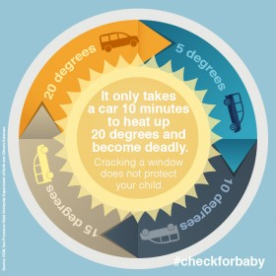

Early Head Start (Birth to 3 Years Old)
Infant and toddler care is unique and should not be viewed as a scaled down version of a preschool Program, day care or as “babysitting.” The needs of infants and toddlers make this care distinctively different from the care of older children.
•Between birth and three (3) years of age, the physical growth and development of infants and toddlers is far more rapid than during any other period in life.
•Younger children are more dependent on the caregiver, more vulnerable, and less able to cope with discomfort or stress of any kind.
•Physical, social, emotional and cognitive aspects of development are more interrelated for this age group and children require consistent, nurturing relationships with their caregiver.
This rapid early development is best understood in three (3) different stages:
(1) Young infants (birth to nine months)
(2) mobile infants (six to eighteen months)
(3) toddler (16 to 36 months).
The overlap in these stages represents the different rates of development among infants and toddlers; however, these stages serve to emphasize how a young child’s individual needs are shaped by a particular stage of development. For example, the care of a highly dependent young infant who is still establishing patterns for sleeping and eating will look different from the care of the toddler who is beginning to develop their independence. The environment, and experiences and interactions a caregiver provides will be tailored to meet the unique needs of each age group, taking into account individual child needs.
•Young infants – caregivers strive to nurture feelings or security and trust through consistent and nurturing interactions.
•Mobile infants- caregivers serve as a safe, readily available base from which the infant/toddler can venture out and explore, confident that they may return at any time for loving contact and support.
•Toddlers- caregivers understand that toddlers are experiencing greater awareness of separateness and independence from the adults in their lives. Caregivers support children’s growing sense of initiative, independence, and individuality, while at the same time helping the toddlers learn to interact cooperatively as a member of a group.
To promote development and competency in all domains, the PCI Early Head Start Program implements the following infant/toddler care practices:
•Primary Care Giving– Each infant will be assigned one (1) or two (2) primary caregivers who feed, change, nurture and play with the baby, allowing the baby to form meaningful, secure relationships with the caregiver. Infants and toddlers learn within the context of trusting relationships. According to Jillian Rodd (1966), “An infant who has at least one secure attachment will be more likely to develop secure relationships with other people in the world, such as grandparents, other familiar adults and children, and childcare and educational professionals. An infant’s relationships with other people, such as early childhood professionals, are not considered to threaten the mother-child bond but rather to contribute to the infant’s developing sense of trust in the world and the people in it.”
•Small Group Size – The center-based program has no more than eight (8) infants and toddlers in a group, and no more than two (2) high-risk (children with special needs) infants per group.
Nutrition
The “Color Me Healthy” curriculum and the “I Am Moving, I Am Learning” program is utilized in the classroom. The curriculum and program emphasize the importance of making healthy food choices and participating in physical activities every day. “Color Me Healthy” and “I Am Moving, I Am Learning” includes classroom activities such as song, games, and imaginary trips all developed especially for preschool age children.
- HEALTH
Disabilities Services
Since 1972, Head Start has operated under the requirements of a Congressional mandate to make available, at a minimum, ten percent (10%) of its enrollment opportunities to children with disabilities. Head Start staff plays an important role in helping to identify children who may be in need of special services. Staff actively recruits families and offers enrollment opportunities for children with disabilities. The Program collaborates with other community agencies that assist children with disabilities to ensure that children are identified and provided a full range of services to meet individual needs. Head Start's philosophy of inclusion supports the rights of all children to be active participants in natural settings within their communities. All children enrolled in the Head Start/Early Head Start program will receive a developmental screening conducted by the classroom teacher within forty-five (45) days of the child’s enrollment date with parental consent.
The purpose of the Ages & Stages is to obtain a sampling of a child’s skills and behavior in order to identify the child who should be referred for more comprehensive evaluation. Further assessment will determine the existence of a delay or disability that may cause learning problems. When the decision is made to refer a child for further testing whether it’s because of failed and/or previous services, a Multidisciplinary Team Staffing will be conducted with the parent and key staff to discuss the developmental screenings and assessments which indicated a concern. The Education Center Coordinator or the classroom teacher should forward the referral information with parental consent to the Disability/Mental Health staff, who will serve as an advocate for the family.
Children with Special Needs
Early Head Start
Children, ages six weeks to three years, also receive the “Ages & Stages Infant-Toddler.” Any child needing further assessment will be referred to an Early Childhood Intervention (ECI) Program upon written permission from the parent. If the assessment results in a developmental delay of 25% or more in one area the Part-C/ Early Childhood Intervention program (ECI) will arrange for evaluations and the development of an Individual Family Service Plan (IFSP) to address the child’s individual and family needs. The Disability/Mental Health staff will assist the family throughout this process.
Head Start
Children three to five years of age with a suspected delay/disability are referred to the Local Education Agency (LEA) (Independent School District) (ISD) once parental consent has been obtained. Services will be provided to address developmental needs through the implementation of an (IEP) Individual Educational Plan.

Mental Health
Head Start embraces a vision of “Mental Wellness” for all children, parents and staff. The mental health goals are interwoven throughout all services and activities offered by the program. The ultimate goal is that all participating children will be “Socially Prepared” when they complete Head Start and transition to kindergarten.
The social & emotional well-being of every child is important to the program. Children are taught skills which will develop a good sense of self-esteem, self-identity and self-worth. Additional social skills activities will be part of the classroom teacher’s lesson planning activities. Children will be taught in following the rules, listening skills, following directions, sharing, cooperation, self-discipline and any others social skills.
All children enrolled in Head Start/Early Head Start will receive an initial screening for social, emotional and behavioral abilities. When children are having difficulties with behavioral and/or emotional well-being, the program has a Licensed Mental Health Consultants available to our program on a consultative basis. The Consultant is available to our staff, parents and children when assistance is requested.
Parental permission will always be secured before any mental health services are provided directly for a child. The Consultant will work with the parents and staff for a child who may need a more direct strategy in increasing their social abilities.
When any child is having difficulties adjusting to daily routine, following rules, and displaying self-discipline, the Disability/Mental Health staff, Mental Health Consultant, Education Center Coordinator and teacher will always be willing to conference with the parents to develop possible strategies to assist the child in making necessary modifications for home and school environment.
PCI will also provide assistance/guidance in addressing children with challenging behaviors from a trained staff and/or Mental Health Consultant.
PCI will not expel a child because of their behavior. Also, suspension is prohibited or severely limited due to a child’s behavior which poses a health and safety concern.
Levels of Mental Health Interventions
Prevention: (Universal) activities and strategies are designed to help staff, children and families learn and to practice good mental wellness skills, which helps them to have emotional growth and development. The program staff helps to develop and create experiences, which build positive relationships between the children, staff and families. Parent and staff trainings are provided through the program and through established community mental health agencies.
Identification/Referral: Early Intervention is a key factor for a child who may need a little extra help developmentally. Our program conducts classroom observations, screenings, formal and informal emotional and behavioral assessments to assist in identifying the possible need for a referral for mental health services.
Treatment: Once it has been determined that a child is eligible for mental health program services, a collaborative individualized plan is developed with input from parent, HS staff, and mental health consultant/provider.

Health Services and Requirements - Source of Ongoing Health Care
All children need a Primary Care Provider to provide on-going health care. If your child does not have a source of ongoing healthcare, we will assist you in accessing a source of care. We can provide a list of doctors and obtain information about Medicaid services.

- Current Physical Examinations from a licensed physician must be in accordance to the Texas Health Steps Medical Periodicity Schedule within 90 days of entering the program – Children and young people need to see their doctor regularly even when they are not sick. This is called a well-child visit and helps them stay healthy. Preschool, physical examinations (well child check-ups) performed within one year prior to the date of school entry are acceptable for enrollment purposes. Medicaid insurance covers one physical exam per year. A physical exam should cover these services: Health History, Nutrition Screening, Developmental, Mental Health, TB Questioner, Height and Weight, BMI, Blood Pressure, Immunizations, Vision and Hearing Screen and Laboratory Tests including a Lead Screening, Hematocrit and/or Hemoglobin.
PCI health staff are certified in Hearing and Vision screening in the event it is missing on the child’s physical exam and will ensure it is conducted within 45 days of child’s enrollment.
- Physical Examinations - For Infants and Toddlers Entering Early Head Start: At the time of enrollment for infants and toddlers, a physical examination including a lead screening is required that is dated closest to the current age of the child in accordance with the well child schedule. Your child may also need documentation of a TB screening done at age 12 months.
  - Lead Screenings - If your child had a lead screening at 12 and 24 months, please provide a copy of the latest lead results. If your child did not have a lead screening done at 12 or 24 months, it should be done between 36 and 72 months (3-6 years old). Ask your doctor to send the results to PCI Head Start. The child only needs to have one lead screen performed, not one every year.
  - Immunizations - In accordance with the Immunization Law of the Texas Department of State Health Services all Head Start children must be up to date on their immunizations on the first day of Head Start attendance. All children that are not up to date will be given 30 days to become complete. After 30 days, if the child is not up-to-date, PCI staff will assist parents in obtaining the child’s immunizations.
  - Dental Examinations - from a licensed Dentist – Good oral health for infants, toddlers and pre-school children serves as a precursor to adult oral health and is essential for a child’s behavioral, speech, language and overall growth and development. Head Start requires that all children must have a dental home and receive a dental examination performed by a dentist within 90 days of entry into the program. The program will assist any parent in identifying a dental home or a local dentist that serves children and will assist in any identified dental follow-up and treatment needs.

The ongoing accessibility to dental care should occur preferably every six months or a minimum annually from the date of the first examination. If a child is not up to date, the program will assist parents in making necessary arrangements to keep children up to date. A Head Start dental form should be completed by the dentist and returned to the program to verify services/treatment received.

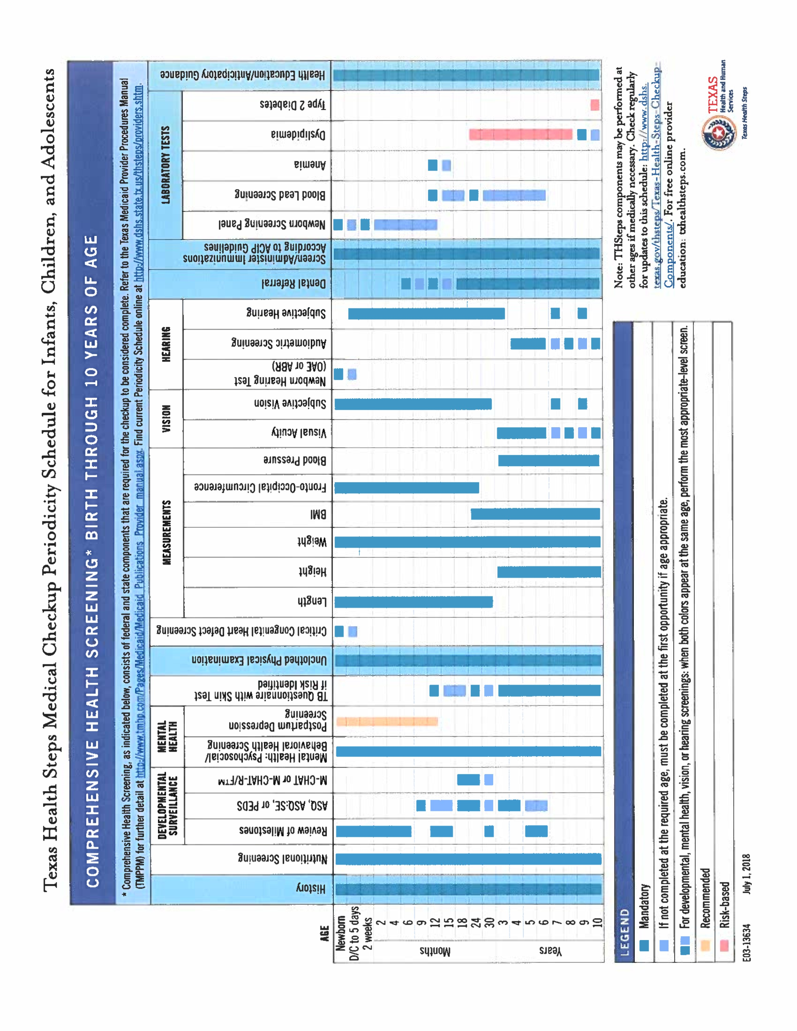

Information has been obtained from the CDC U.S. Centers for Disease Control and prevention.
For additional information please visit - https://www.cdc.gov/vaccines/hcp/imz-schedules

Daily Health Observations
A daily health check of each child is made upon arrival in the presence of the parent or caregiver. To prevent the spread of infection, communication between teachers and parents about the child’s health status is vital to identify any specific signs or symptoms of illness.
Children with any symptoms of illness will not be allowed to remain in the center:
- Fever – (Oral) temperature of 101 degrees or more, Tympanic (ear) or axillary (armpit) temperature above 100 degrees.
- An unexplained rash
- Two or more Vomiting episodes (in the past 24 hours)
- Diarrhea – Three or more watery stools in 24 hours.
- Thick, yellow, green drainage from the nose.
- Eye Infection – Thick mucus or pus draining from eye.
- Skin Infections – Impetigo, Scabies or other skin infections: The child may return 24 hours after starting treatment or when Physician has released.
- A contagious disease (ex. Chicken pox)
Illness and Exclusion
If children develop an illness at a center the child will be pulled out of classroom away from other children and supervised until parent can pick child up.
Medical Emergency Information
During the enrollment process, parents must complete and sign a Pick-up Authorization & Emergency Contact/Information form that is kept in the classroom accessible to the teacher in case of an emergency. Medical Emergency guide and Emergency Preparedness plan is in each classroom and office. Procedure for handling health emergencies are located in the office.
The agency emergency preparedness plan is located on each teacher board and administrative board.
Note: Emergency Contact Information should always be up to date for notification to be made should children become ill.
Accident Reports
Despite all efforts to promote safety and injury prevention, should a child be involved in an accident or receive an injury, it is important to communicate this to parents both verbally and in writing. An Incident/Illness report form will be completed, and a copy given to the parent.
Medication Administration
Whenever possible, arrangements should be made with the family and the child's physician to schedule administration of medication during times when the child is most likely to be under parental supervision. When medication must be administered in the classroom, a "Special Consent for Administration of Medication" form must be completed prior to administration of any medication in the center. All medication will be stored in a locked cabinet unless the physician prescribes other orders. Medication, diaper ointment, insect repellant, or sunscreen must be in the original container with a current date and label with directions for use from the physician.
Epinephrine Auto-Injectors
A written emergency treatment plan will be provided by the child physician and provided to the parent prior to receiving the Epinephrine auto-injector to the center. The center staff is trained how to administer an epinephrine auto injector by PCI’s RN. Parent will fill out the “Special Consent for Administration of Medication" form. Epinephrine auto injector will be always stored under lock and key when not in use. Annual training will be given to employees and volunteers who will be allowed to administer epinephrine auto-injectors. Epinephrine auto-injector will be sent home with parents for disposal.
Tooth Brushing
Each classroom will have a supervised tooth brushing activity twice a day that models and teaches good dental hygiene. Toothbrushes are labeled with your child’s full name to prevent any cross contamination.

- NUTRITION
Child Nutrition Services
PCI Nutrition Services participates with the USDA Child and Adult Care Food Program (CACFP) to provide each child with nutritious meals and snacks to meet 1/2 to 2/3 of his/her daily nutritional needs. Therefore, all children enrolled in full-day, part-day and double session will be offered breakfast, lunch and/or a p.m. snack. A Registered Dietitian develop menus to comply with CACFP meal patterns, and serving sizes are appropriate for each child’s age. PCI’s menu offers foods that vary in culture, color, texture, temperature, size and shape. All meals and snacks are served in a family style meal service setting. Infants are fed on demand in accordance with written feeding instructions provided by the parent and/or physician. All children are encouraged to eat; however, no child is ever forced to eat.
Breastfeeding
Parents have the right to breastfeed or provide breast milk to the center. A comfortable location will be provided in the center or within a classroom that allows a mother to breastfeed her child. Appropriate storage will be provided for mothers who want to bring in breastmilk for later use at the center. Staff will ensure that breast-fed infants receive only breast milk provided by parents.
PCI purchases all food and drinks needed for each meal and snack for every infant, toddler, and preschool child. In addition, special diet foods are purchased and provided to those children with special nutritional needs as specified in their physician’s written instructions. Parents are not asked to provide any food/drink needed for meals and snacks since PCI receives reimbursement from USDA specifically for this purpose.
Meals
Family style eating with balanced, nutritious meals gives children an opportunity to learn about healthy eating habits with support from their peers. PCI Head Start's child nutrition services help families in meeting each child's nutritional needs and in establishing good eating habits that nurture healthy development and promote life-long well-being. If necessary, a registered dietitian or nutritionist will follow-up with the child’s parent or guardian to address the child and family's nutritional needs. PCI ensures safe drinking water is available to children. Referrals are made to WIC and other community agencies when necessary.
It is the parent's responsibility to inform the Teacher or Family Service Worker their child has any food allergies or if the child is on a special diet. A doctor's statement is required for special diets for medical reasons in order for specific adjustments to be made to the meals served.
Mealtime is also used as a learning experience. Volunteers and staff are expected to sit with the children and to model healthy eating habits and table manners. Staff also stimulate social interaction and promote language development and social skills. All children in Head Start/ Early Head Start are served breakfast, lunch, and one snack. These meals must be consumed at the center. No outside meals may be provided at these designated times.
Food items high in nutrients and low in fat, sugar and salt are offered to the children. For parents wanting to help their children’s classroom celebrate special occasions, these occasions must be approved with the Education Center Coordinator, and Nutrition Staff. Food for all special pre-planned events must be store bought and pre-packaged.

- FAMILY AND COMMUNITY PARTNERSHIPS
Family Engagement
The PCI Board of Directors, Policy Council, CEO and Staff advocate for Head Start families. The partnership between parents and Head Start and Early Head Start staff is fundamental to children's current and future success in school readiness and aids the family in areas of strengthening relationships, educational needs and ability to come into contact with entities that will benefit their family as a whole. Staff use all resources available to identify specific strategies that support this endeavor. PCI ensures that every family receives all the information, access to community services, and benefits that they are entitled. The Head Start staff work with individual families and with the parent group at each center and helps to link families to services and events in their community. Parental notification procedures are located in the center office. The most recent Licensing inspection is located on the administration and parent board.
Family engagement is an integral part of a successful program for you and your child. Home visits build strong, supportive relationships between staff and parents. Parent workshops are offered that are based on parent interests and parents are given an opportunity to learn and practice leadership skills. Volunteering at PCI provides the opportunity to gain new skills, develop skills you already have and may be used as job experience!
How Can You Be An Active Partner in Head Start/Early Head Start?
✓ Serve as a member of the Policy Council.
✓ Serve on a committee.
✓ Attend parent meetings.
✓ Call other parents (phone tree).
✓ Help in the office.
✓ Work on the newsletter.
✓ Provide childcare as a parent volunteer.
✓ Sign up to serve on the annual program self-assessment.
✓ Help plan a parent meeting.
✓ Give ideas for activities or field trips.
✓ Represent Head Start at a community event.
✓ Read to children in the classroom.
✓ Participate in fatherhood & male involvement activities.
✓ Participate in PCI’s Annual Self-Assessment.
Male Initiative
Head Start and Early Head Start believes in the growing awareness of fathers or male figures having an active role in the lives of children. Fathers are a vital source of caring and nurturing, as well as financial support. They are care givers and role models. Fathers set expectations and help children to accomplish those goals. Developing strong relationship is not only important to the children and mothers, but also to the men themselves. The PCI Head Start/Early Head Start Program provides activities that will give the men an opportunity to get to know other men in the program and explore what the program can offer them and what in turn they can offer to the Head Start/Early Head Start Program. Parent/Child Incorporated schedules monthly Male Initiative meetings to provide needed information and to obtain input from the male group on recommendations that they feel would aid the programs. Training is also offered to assist them in their role as a teacher for the children.
In-Kind
The Federal Government requires that twenty percent (20%) of the Head Start and the Early Head Start grants be matched with contributions from parents and the community. These contributions are called "in-kind". In-kind can be generated by volunteering, attending Head Start activities, donating materials, working on your child's educational goals at home, serving on the Policy Council, and in many other ways. You will be asked to fill out an "in-kind" form when services or materials are provided to the Head Start and Early Head Start Programs. If goods or materials are purchased, please submit the receipt along with the in-kind form.
Parent Rights in the Head Start/Early Head Start Program
- Be supported as the primary educator and nurturer of their child
- Be listened to and treated with respect and dignity at all times
- Ask questions and receive information on any aspect of the Head Start/Early Head Start Program including daily operations, policy making and budgeting
- Express concerns about the program without repercussions to themselves or their child or children
- Express needs and interest and expect a response from the program regarding those expressed needs
- Offer any opinion or suggestions regarding any part of the program and to receive feedback on those suggestions and ideas
- Participate as little or as much as is comfortable
- Be treated as an equal with the staff in supporting the educational goals of the children
- Know that all information gathered will be kept confidential
- Be welcomed and encouraged to participate in their child’s classroom and/or other center activities at any time

Parent and/or Guardian Responsibilities
- Ensure they comply with agency policies, rules and regulations
- Parent/Guardian are to ensure family members are aware that we can only communicate information with the legal parent/guardian.
- Communicate regularly with the school concerning their child’s progress.
- Provide for the physical needs of the child.
- Participate in Parent-Teacher conferences, Home Visits, Parent Meetings and other activities in which
- their child’s school is involved in.
- Inform the school of any problems or conditions in the home which affect their child
- Cooperate with and support the teachers and the administrators in their efforts to maintain a quality
program.
- Avoiding Offensive or Provocative Clothing: Parents should avoid wearing clothing with offensive language or graphics, as well as clothing that might be considered overly revealing or provocative.
- No Pajama’s worn when picking up or dropping off your child(ren). Please see examples below:

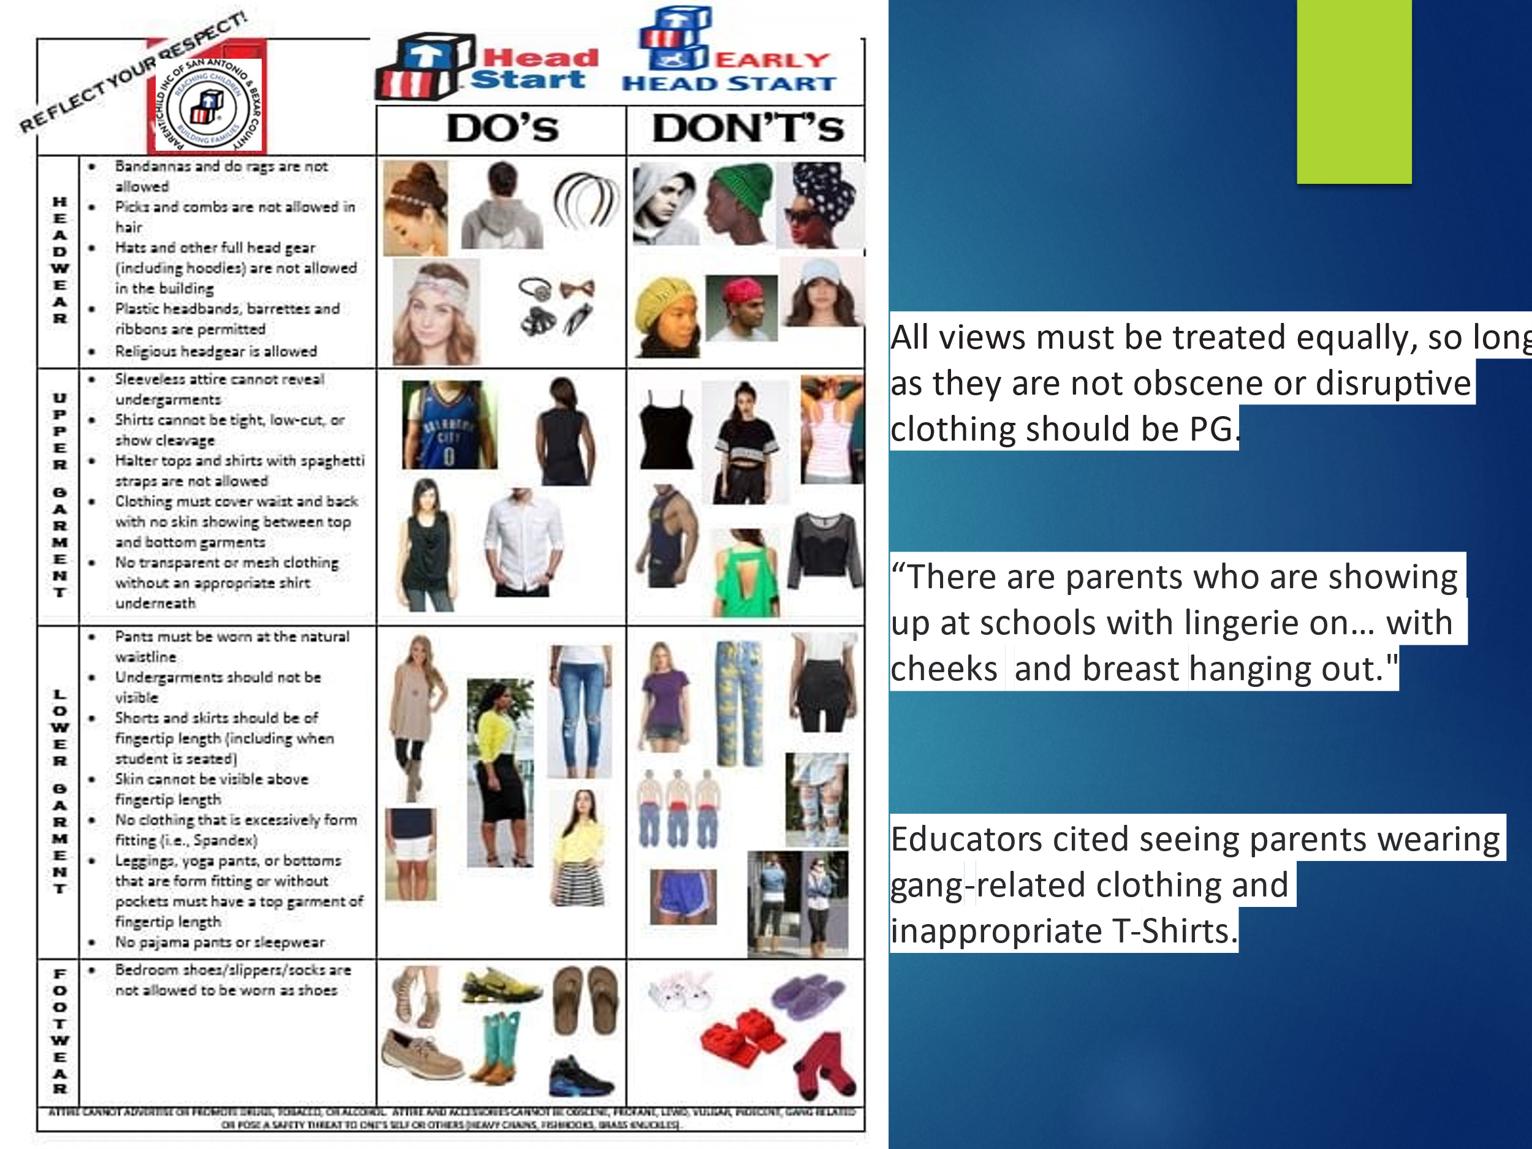

Dollar Per Child Campaign
PCI Parents, Staff, Consultants, Vendors and Community Partners are asked to contribute to Dollar Per Child Campaign that exclusively funds the Texas Head Start Association (THSA) and the National Head Start Association (NHSA) advocacy activities for the State of Texas and all Head Start programs, respectively. NHSA is the only national organization dedicated exclusively to promoting and protecting the Head Start and Early Head Start Programs, a comprehensive preschool program that helps low-income children and their families. NHSA works directly with Congress and the Administration to maintain the voice of Head Start and Early Head Start children, families and staff to continue to provide and receive quality program services. Because of its legislative activities, NHSA and THSA must be supported entirely by non-federal funds. No individual or agency membership dues are used for legislative activities. Because of these restrictions, we must rely directly on the support of the Head Start/Early Head Start Community to continue the effort of the Head Start and Early Head Start Programs.
Policy Council
The Policy Council is the parents' voice in major program decisions including such items as our recruitment plan, personnel policies, budgets and funding proposals. Each PCI Early Learning Center Elects Policy Council Head Start and Early Head Start Representatives and one Alternate according to the approved Policy Council Make Up and By-Laws. These individuals represent their Center Parent Committee at monthly Council meetings and report what is not deemed confidential during the monthly parent meetings. The Policy Council, along with the Board of Directors through a shared governance system, ensures PCI’s Head Start/ Early Head Start programs remain in compliance with federal regulations. The Policy Council meets monthly at a date and time approved by the Council.
Policy Council Responsibilities
- Must attend monthly meetings and notify staff and their alternate in advance if unable to attend.
- Attend Shared Program Governance Meetings and Trainings.
  - Approve and submit to the governing body (Board of Directors) decisions made at monthly Policy Council Meetings.
- Serve as an advocate for all PCI Head Start/Early Head Start families and ensure that the best interest of the agency is taken care of and protected.
- Participate in the Agency’s Annual Self-Assessment.
  - Attend and facilitate the Center Parent Committee meetings and provide the leadership and assistance needed.
- Serve on working committees that help the PCI Head Start/Early Head Start programs.
Early Head Start - Child Care Partnership (EHS-CCP)
The Early Head Start-Child Care Partnership grant is a new opportunity for Early Head Start programs such as PCI to support and partner with community childcare providers to expand the number of high-quality services for infants and toddlers. These new partnerships support in meeting the Head Start Program Performance Standards (HSPPS) and providing comprehensive services. Currently, PCI partners with four (4) childcare providers with a total of 120 qualified children and families who also receive support from Child Care Services (CCS).
The EHS-CCP program brings together the strengths of childcare and EHS programs. We realize childcare providers have experience providing care that is strongly grounded in the cultural, linguistic, and social needs of the families and their local communities. Through the EHS-CCP program, childcare centers have access to resources to provide the comprehensive services needed to support better outcomes for the nation's most vulnerable children. EHS is a research-based program that emphasizes the importance of responsive and caring relationships to support the optimal development of infants and toddlers. EHS provides comprehensive family-centered services that adhere to the Head Start Program Performance Standards (HSPPS) to support high-quality learning environments. Integrating EHS comprehensive services and resources into the array of traditional childcare settings creates new opportunities to improve outcomes for infants, toddlers, and their families.
- PROGRAM DESIGN AND MANAGEMENT
Program Design and Management Introduction

A Policy Council is established and responsible for the direction of the Head Start/Early Head Start program, along with the Board of Directors in accordance with the Head Start Act, Performance Standards and other federal regulations. The Policy Council is made up of parents representing each PCI Early Learning Center and EHS-CCP Center, along with community members. PCI’s Policy Council works in collaboration with the governing board in establishing short and long-term goals, which include appointing executive personnel, fiscal and program policies as well as promote Early Head Start services throughout the service delivery area. The Policy Council participates in the Agency’s Annual Self-Assessment that is used to assess current program operations and assist in planning future direction.

Management ensures the program provides quality services to children and families, is financially sound, meets all state and federal regulations, and supervises program staff.
Career Development and Training
Parent/Child Incorporated provides staff and volunteers at all levels and in all programs with training to enhance job performance and opportunities for career advancement. A goal of the agency is also to provide opportunities for parents to learn job skills and gain on-site experience in order for them to be more marketable in the employment arena industry. Professional Development Training is on-going and offered year-round.

Pre-Service and On-Going Training
Parent/Child Incorporated provides pre-service training every school year to assist staff in acquiring and increasing their knowledge and skills needed to fulfill their job responsibilities in accordance with PCI Polices, the Head Start Performance Standards, and other regulations as required. PCI Early Learning Centers are closed during Pre-Service Week.
Head Start provides parents with opportunities to participate in policy and decision-making throughout the program. Parents are involved in such areas as program planning and implementation, volunteering, parent committees, policy council committee membership, and program self-assessment. All staff are trained on Child Abuse policies annually and on an on-going basis.
Parent Concerns
When parents have concerns regarding the center and/or their child’s success at school, they should make an appointment to meet with the appropriate staff member. This person is usually the teacher and Education Center Coordinator. Head Start Teachers have a conference period from 2:45 p.m.-3:15 p.m. Early Head Start/EHS Expansion would be before or after school. If the concern cannot be resolved in this manner, please use the Parent and Community Complaint Procedure.
Parent and Community Complaint Procedures
Head Start is required to have procedures for resolving parent/community complaints –These are the steps to follow, if you have a concern or problem regarding your child’s services in the Head Start/Early Head Start Program:

- First, discuss the concern or problem with your child’s teacher. If the concern or problem is not resolved at this level, or the concern is with the teacher, then…
- Second, discuss the concern or problem with the Education Center Coordinator.
(The Education Center Coordinator may contact additional Head Start staff or administrators to help resolve your concern or problem. Should this step not provide a satisfactory resolution), then,
- Third, contact the Head Start/Early Head Start Operations Coordinator at PCI Headquarters, 210-226-6232.
- Fourth, contact would be made to the Chief Executive Officer/HS/EHS Director’s Office at 210-226-6232.
These are the steps to follow, if a member of the community has a concern or problem regarding PCI Head Start/Early Head Start, please follow the procedures listed below:
1. First, discuss the concern or problem with the Education Center Coordinator. If the concern or problem is not resolved at this level, then
2. Second, discuss the concern or problem with the Education Center Coordinator’s supervisor, the HS/EHS Operations Coordinator at 210-226-6232, if the concern or problem is not resolved, then
3. Third, contact the Chief Executive Officer/HS/EHS Director’s Office at 210-226-6232.
At each center, a copy of the Head Start Performance Standards, The Health and Human Service Licensing Manual, and the PCI Head Start/Early Head Start Administrative Guide Policies & Procedures Manual are available to you for review at any time. The center’s last licensing visit can be found on the center administrative board.
- ADULT CODE OF CONDUCT
We want every Head Start/Early Head Start center to be a happy place where children can find an atmosphere conducive to learning and to enhancing their self-esteem. We want every site to be a welcoming place where staff and parents can work together for the welfare of children. Therefore, the following policies will be adhered to:

  - No child will be subjected to physical punishment while on Head Start premises by any staff person, parent, volunteer or visitor.
  - No child will be subjected to verbal abuse, name calling, ridicule, or cursing by a staff person, parent, volunteer, visitor while on Head Start premises.
  - No harsh words, cursing, or other abusive language will be exchanged between adults in or around the site, especially in the presence of children.
  - No threats will be made by any adult to any other adult in or around the site.
  - PCI is a smoke-free environment. No smoking is permitted on any Head Start/ Early Head Start premises, which includes the parking lot area. Any person unwilling to abide by these policies will be required to leave the premises. A conference will be held with the person or persons involved and appropriate Head Start staff to determine the necessary action. Action may include permanent dismissal of staff, children or parents from the Head Start/Early Head Start Program. In cases where cooperation cannot be achieved, the proper authorities will be contacted for further action.
- PCI follows the General Firearms Laws of the State of Texas to include the Concealed Handgun Laws. Signs are posted at all Early Learning Centers as required by State Law. Weapons are prohibited on the premises of all PCI Early Learning Centers and Administrative Offices.
- PCI Early Learning Centers are considered to be in a Gang Free Zone. The Gang Free Zone is within 1000 feet of each Early Learning Center.
- Known Registered Sex Offenders will not be permitted to be on the premises.

Special Notice: Picking up children while under the influence of drugs/alcohol is considered inappropriate by our program. If a parent/guardian is under the influence of drugs/alcohol or impaired, the program may call other persons authorized to pick up the child. If the adult is so impaired that the child would be placed at risk of serious and immediate harm, the police will be called.
- IMPORTANT POLICIES
Confidentiality
All information concerning your child and family will remain confidential. Your written consent will be obtained before any information is forwarded to another agency. We ask that you discuss classroom matters relating to children and volunteers only with the Head Start/EHS staff. It is preferable to find time outside of classroom time to share your ideas or concerns with staff. You can also use this time to relate to an individual child’s success or difficulty. If you have a concern or questions with program policies or routine, please feel free to discuss them privately with the Education Center Coordinator so that it may be worked out.
Confidentiality
All enrollment information provided to PCI is kept CONFIDENTIAL. Every Child/Family File is kept in locked cabinet and only authorized personnel have access to the file. There are instances when information in the Child/Family File may need to be released. If a parent requests information to be released, he/she must do so in writing. If another agency or PCI is requesting for the information to be released, the parent/guardian MUST SIGN the “Authorization for Release of Child/Family Information”. No information will be released unless the procedure listed above is completed and has been authorized by the Head Start/Early Head Start Coordinator. In addition, no information will be released to persons not listed as part of the household. Information will be released to a non-custodial parent who provides a legal document stating he/she has a right to such information. Any concerns pertaining to the child enrolled will only be discussed with the parent or legal guardian listed on the application.
Right of Access
Head Start strongly encourages parents to participate in their child's preschool experience. Parents/guardians are welcome at the center at any time. Head Start/Early Head Start is here to support your family.

Attendance Policy

A procedure is in place to ensure children are safe when they do not arrive at the center. If a child is unexpectedly absent and the parent has not contacted the Education Center Coordinator within one hour of the center opening, the center staff call the parent to ensure the child’s well-being.
Parents are required to sign a Family Partnership Agreement that states they agree to the following:
- Bring their child to the Center every day, on time, and pick up their child each afternoon, on time.
- If their child is absent, a note should be provided, and a telephone call made to the Education Center Coordinator or Family Service Worker indicating the reason for the absence. The reasons for absenteeism are recorded in the child’s file.
- A home visit will be conducted should the center staff not be able to contact the parent/guardian after three (3) consecutive days.
- Ten (10) consecutive absences without contact or approval will result in the withdrawal of the child(ren) from the program.
- Only serious medical or personal reasons will be considered for extended absences, not to exceed 30 days, and must be requested in writing by parent/legal guardian.

If your child is unable to come to the center or you will be late getting your child to his/her classroom, please call the center before or by 7:30 a.m.

Child Abuse Reporting Policy
If a parent suspects that his/her child has been abused or sexually molested, he/she must report it immediately to the toll-free Child Abuse Hotline number (1-800-252-5400), available 24 hours a day. PCI encourages parents to report such acts to their ECC, also. A parent may also contact the licensing office via the HHS website www.hhs.state.tx.us/childcare) or call 210-337-3399.
The staff who work with your child and family care about your health, safety and well-being. We are required by law to report suspected child abuse or neglect. Being a parent is no easy task and we are here to support you by offering guidance in alternative discipline techniques and resources to parenting classes and other useful workshops.
Head Start staff is required by state law to report any suspected or identified child abuse to Department of Human Services (DHS). Head Start staff will support families who have an involvement with DHS and will preserve absolute confidentiality of all records pertaining to a report in accordance with state law.
All suspected and/or known cases of child abuse or neglect, to include sexual abuse, must be reported to the Health and Human Services (HHS) as soon as one becomes aware of the situation. Parent Child Incorporated staff receives a minimum of 1 hour of training annually in Child Abuse and Neglect and the warning signs. Outside consultants and PCI staff conduct training.
Suspected and/or known child abuse or neglect reported to PCI staff, regardless of if it occurs when child is in the care of PCI or not, will be reported immediately to HHS.
Any staff accused of inappropriate interaction with children will be reported to HHS. If any staff person is found guilty, PCI will take the necessary corrective action. This action will remain confidential and will not be shared with the parent.
RECOGNIZING CHILD ABUSE SIGNS
The Child:
- Shows sudden changes in behavior or school performance.
- Has not received help for physical or medical problems brought to the parents' attention.
- Has learning problems that cannot be attributed to specific physical or psychological causes.
- Is always watchful, as though preparing for something bad to happen.
- Lacks adult supervision.
- Is overly compliant, an overachiever, or too responsible; or
- Does not want to go home.

The Parent:
- Shows little concern for the child, rarely responding to the school's requests for information, for conferences, or for home visits.
- Denies the existence of -- or blames the child for -- the child's problems in school or at home.
- Asks the classroom teacher to use harsh physical discipline if the child misbehaves.
- Sees the child entirely bad, worthless, or burdensome:
- Demands perfection or a level of physical or academic performance the child cannot achieve; or
- Looks primarily to the child for care, attention, and satisfaction of emotional needs.
The Parent and Child:
- Rarely touch or look at each other.
- Consider their relationship entirely negative; or
- State that they do not like each other.

None of these signs prove that child abuse is present in a family. Any of them may be found in any parent or child at one time or another. But when these signs appear repeatedly or in combination, they should cause the educator to take a closer look at the situation and to consider the possibility of child abuse. That second look may reveal further signs of abuse or signs of a particular kind of child abuse.

Center Closures Due to Inclement Weather & Push Notification System

PCI has a process in place should the agency have to close down due to inclement weather.
- The CEO will make the decision, in the best interest of the agency, on whether to close PCI Centers/Offices.
- The CEO will contact all Executives.
- Executives will contact staff in their departments, including the Education Center Coordinators to advise them of the closure.
- KSAT 12 News will be contacted about the closure.
- ECCs and Family Service Workers will advise parents of the closure and watch the local news for further details.
- Push Notification will be sent out to all parents and staff with a registered cell phone.
- All Social Media will be updated with the closure information.

PCI Parent Notification System
Parent/Child Incorporated uses a text-message notification system through the mobile phone networks to update parents quickly and efficiently. This is the easiest and most-effective solution for PCI to communicate with you quickly and accurately. We are committed to you and to your child's education and safety.

Notifications will be sent for the following reasons:
- Emergency notifications are used during critical incidents where a child, staff member or parent’s safety is in immediate jeopardy such as cancelations, delays, lockdowns, evacuations, relocations, and other emergencies due to the weather, power outages, fog or other unforeseen circumstances.
- Routine notifications do not directly affect the safety of students, staff or parents. These notifications include important upcoming events.

To sign up, text "JOIN" to (210) 226-6232 on your mobile phone.

Importance of Accurate Contact Information:
The most important thing parents can do is verify the accuracy of their contact information for the text notification to work effectively and efficiently. The notification system will send a text message to the mobile phone you specify. Please be sure to keep your contact information up to date.

- HEAD START FREQUENTLY ASKED QUESTIONS (FAQ)
Does my child need to be 3 years old by September 1st to qualify? Children do not have to be 3 years old by September 1st to qualify for Parent/Child Incorporated’s Head Start Program.
Does my child need to be potty-trained? Children do not have to be potty-trained to qualify for services. Discussion can take place with the teacher when the child is ready.
Are enrollees required to wear uniforms? Enrollees are not required to wear uniforms in Head Start, but if the classroom is located in a School District Building, the parents are asked to abide by their dress code.
What supplies are required for licensing? Child Care Licensing requires that the parents provide a change of clothing appropriate for the season. These are the only supplies required.
How can I enroll my child/children? You can enroll your child/children by calling the In-Take Line at 210-475-5149, call 210-226-6232 for the center nearest you or fill out an application online on PCI’s Website-www.parentchildinc.com.There you will find information you need under “Enrollment” located on the dashboard.
Visit the Parent/Child Incorporated website whenever possible for all information on our agency.
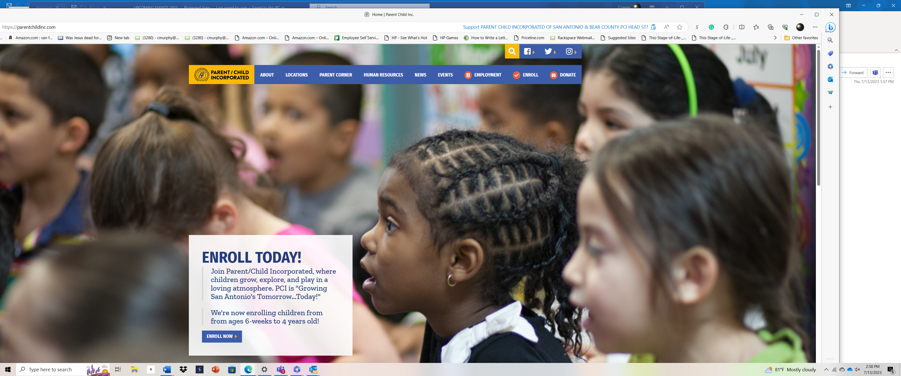

- IMPORTANT PHONE NUMBERS
EMERGENCY SERVICES
- Emergency (Police/Fire/Ambulance) – 911
- Non-emergency Fire – 210-207-7744
- Non-Emergency Police – 210-207-7273
- Bexar County Sheriff’s Department Non-Emergency Dispatch – 210-335-6000
- Ambulance - Non-Emergency – 210-207-7744
- Texas Department of Public Safety – 210-531-2200
- Child Abuse Hot Line – 1-800-252-5400
- Methodist Hospital – 210-575-4000
- Metropolitan Methodist Hospital – 210-757-2200
- University Hospital – 210-358-4000
- Northeast Methodist Hospital – 210-757-7000
- Baptist Medical Center – 210-297-7000
- Christus Santa Rosa Children's Hospital – 210-705-6300
- Christus Santa Rosa Northwest Hospital – 210-567-5705
- Southwest General Hospital – 210-921-2000
- TTY RELAY Texas – 711 or 1-800-676-3777
- United Way – 211
- San Antonio Food Bank – 210-337-3663
- Poison Control Center – 1-800-222-1222
- Child Care Regulations Texas Health Human Services – 210-337-3399
TRANSPORTATION
- San Antonio International Airport – General Information – 210-207-3433
- VIA Metropolitan Transit – 210-362-2020 (bus route and schedule)
- SA Trans – Shuttle between airport and hotels (Serving all of San Antonio, military bases,
Bandera, Canyon Lake, Seguin, Boerne, New Braunfels, & Castroville) – 210-281-9900
- Greyhound – 800-231-2222
- Amtrak – 210-223-3226 or 800-872-7245
MISCELLANEOUS
- Telephone Directory – 1-411
- Time/Temperature – 210-226-3232
- Weather Forecast – 210-225-0404

- PCI OBSERVED HOLIDAYS/BREAKS


CENTERS & OFFICE CLOSURES/BREAKS

New Year
’
s Da
y

January 1
st

Martin Luther King Jr. Day

Third Monday in January

Spring Break

Varies between second
/third

week
in
March

Easter Break

Date varies-check agency calendar

Batt
l
e of Flowers Day

Date varies-usually in April

Memorial Day

Last Monday in May

Juneteenth

June
19
th

Independence Day

July 4
th

Summer
Vacation (EHS C
enters)

Week of July 4
th

Labor Day

First Monday in September

Thanksgiving Break

Week of Thanksgiving Day

Winter Break

Begins
last two weeks of December
through day after New Year’s Day

STAFF DEVELOPMENT DAY CLOSURES
PCI holds four Staff Development Days plus one week of Pre-Service Training, the week before the start of each School Year. Refer to the School Year Calendar for exact dates. Children attending East Central, Southwest, will follow the PCI Calendar provided in accordance with school districts.

Veteran’s Day is not observed as a holiday but is celebrated by PCI.

Head Start/Early Head Start Center Directory

Early Learning Center | Address | ECC | Telephone No. | Enrollment  HS/EHS/EHS Exp | School District
Adelina Fritz ELC | 6030 Farragut  SA, TX 78238 | JoAnn Ross | (210) 475-4400  (210) 475-4401 Fax | 34/8/16  Total 58 | Northside
Clarice Roe ELC | 10270 Ladd Rd.  Macdona, TX 78054 | Megan Smith | (210) 475-4408  (210) 475-4409 Fax | 34/0/0  Total 34 | Southwest
PCI Culebra HS Academy | 8031 Culebra Rd.  SA, TX 78251 | Terri Galloway | (210) 475-4444  (210) 475-4445 Fax | 68/16/24  Total 108 | Northside
East Central ELC | 11935 Donop  SA, TX 78223 | Rosalva Lozano | (210) 475-4410  (210) 475-4411 Fax | 34/0/0  Total 34 | East Central
Evelyn L. King ELC | 101 Daniels Rd.  SA, TX 78219 | Mevelon Lott | (210) 475-4412  (210) 475-4413 Fax | 17/16/0  Total 33 | East Central
George Gervin ELC | 6944 S. Sunbelt Dr.  SA, TX 78218 | Katrice Harris | (210) 568-8800  Ext. 2112 ECC/2111 FSW | 68/0/0  Total 68 | George Gervin
Imperial ELC | 111 Imperial  SA, TX 78226 | Erika Treviño | (210) 475-4417  (210) 475-4419 Fax | 34/0/32  Total 66 | Edgewood
Lost Creek ELC | 16352 Judson Rd.  SA, TX 78247 | Rina Lyda | (210) 475-4422  (210) 475-4424 Fax | 51/0/16  Total 67 | Northeast
Meadowood ELC | 12625 Cinco De Mayo  SA, TX 78252 | Valerie Mireles | (210) 475-4407  (210) 475-4405 Fax | 51/0/0  Total 51 | Southwest
PCI Midcrown HS Academy | 8003 Midcrown  SA, TX 78218 | Paloma Benavidez | (210) 475-4442  (210) 475-4443 Fax | 51/24/8  Total 83 | Northeast
PCI EL Academy  Early Head Start | 535 New Laredo Hwy  SA, TX 78211 | Tanya Flores | (210) 475-4438  (210) 475-4439 Fax | 0/0/40  Total 40 | South San
PCI EL Academy  Head Start | 535 New Laredo Hwy  SA, TX 78211 | Stacy Almendarez | (210) 475-4440  (210) 475-4441 Fax | 85/0/0  Total 85 | South San
Pearsall ELC | 6030 Pearsall Rd.  SA, TX 78242 | Rosemary Marin | (210) 475-4425  (210) 475-4426 Fax | 34/16/0  Total 50 | Southwest
Place for Life ELC  Early Head Start | 5820 N.W. Loop 410 SA, TX 78238 | Patricia Cardenas | (210) 475-4429  (210) 475-4430 Fax | 0/0/32  Total 32 | Northside
Place for Life ELC  Head Start | 5820 N.W. Loop 410 SA, TX 78238 | Lisa Sifuentes | (210) 475-4427  (210) 475-4428 Fax | 51/0/0  Total 51 | Northside
Southwest ELC | 11914 Dragon Lane  SA, TX 78252 | Maricella Nuño | (210) 475-4431  (210) 475-4432 Fax | 0/16/0  Total 16 | Southwest
Terry O’Connor ELC | 19810 Hwy 281 South  SA, TX 78221 | Cristal Scott | (210) 475-4420  (210) 475-4421 Fax | 17/16/0  Total 33 | South Side
West Hutchins ELC | 1405 W. Hutchins  SA, TX 78221 | Zella Burns | (210) 475-4433  (210) 475-4434 Fax | 17/16/0  Total 33 | Harlandale

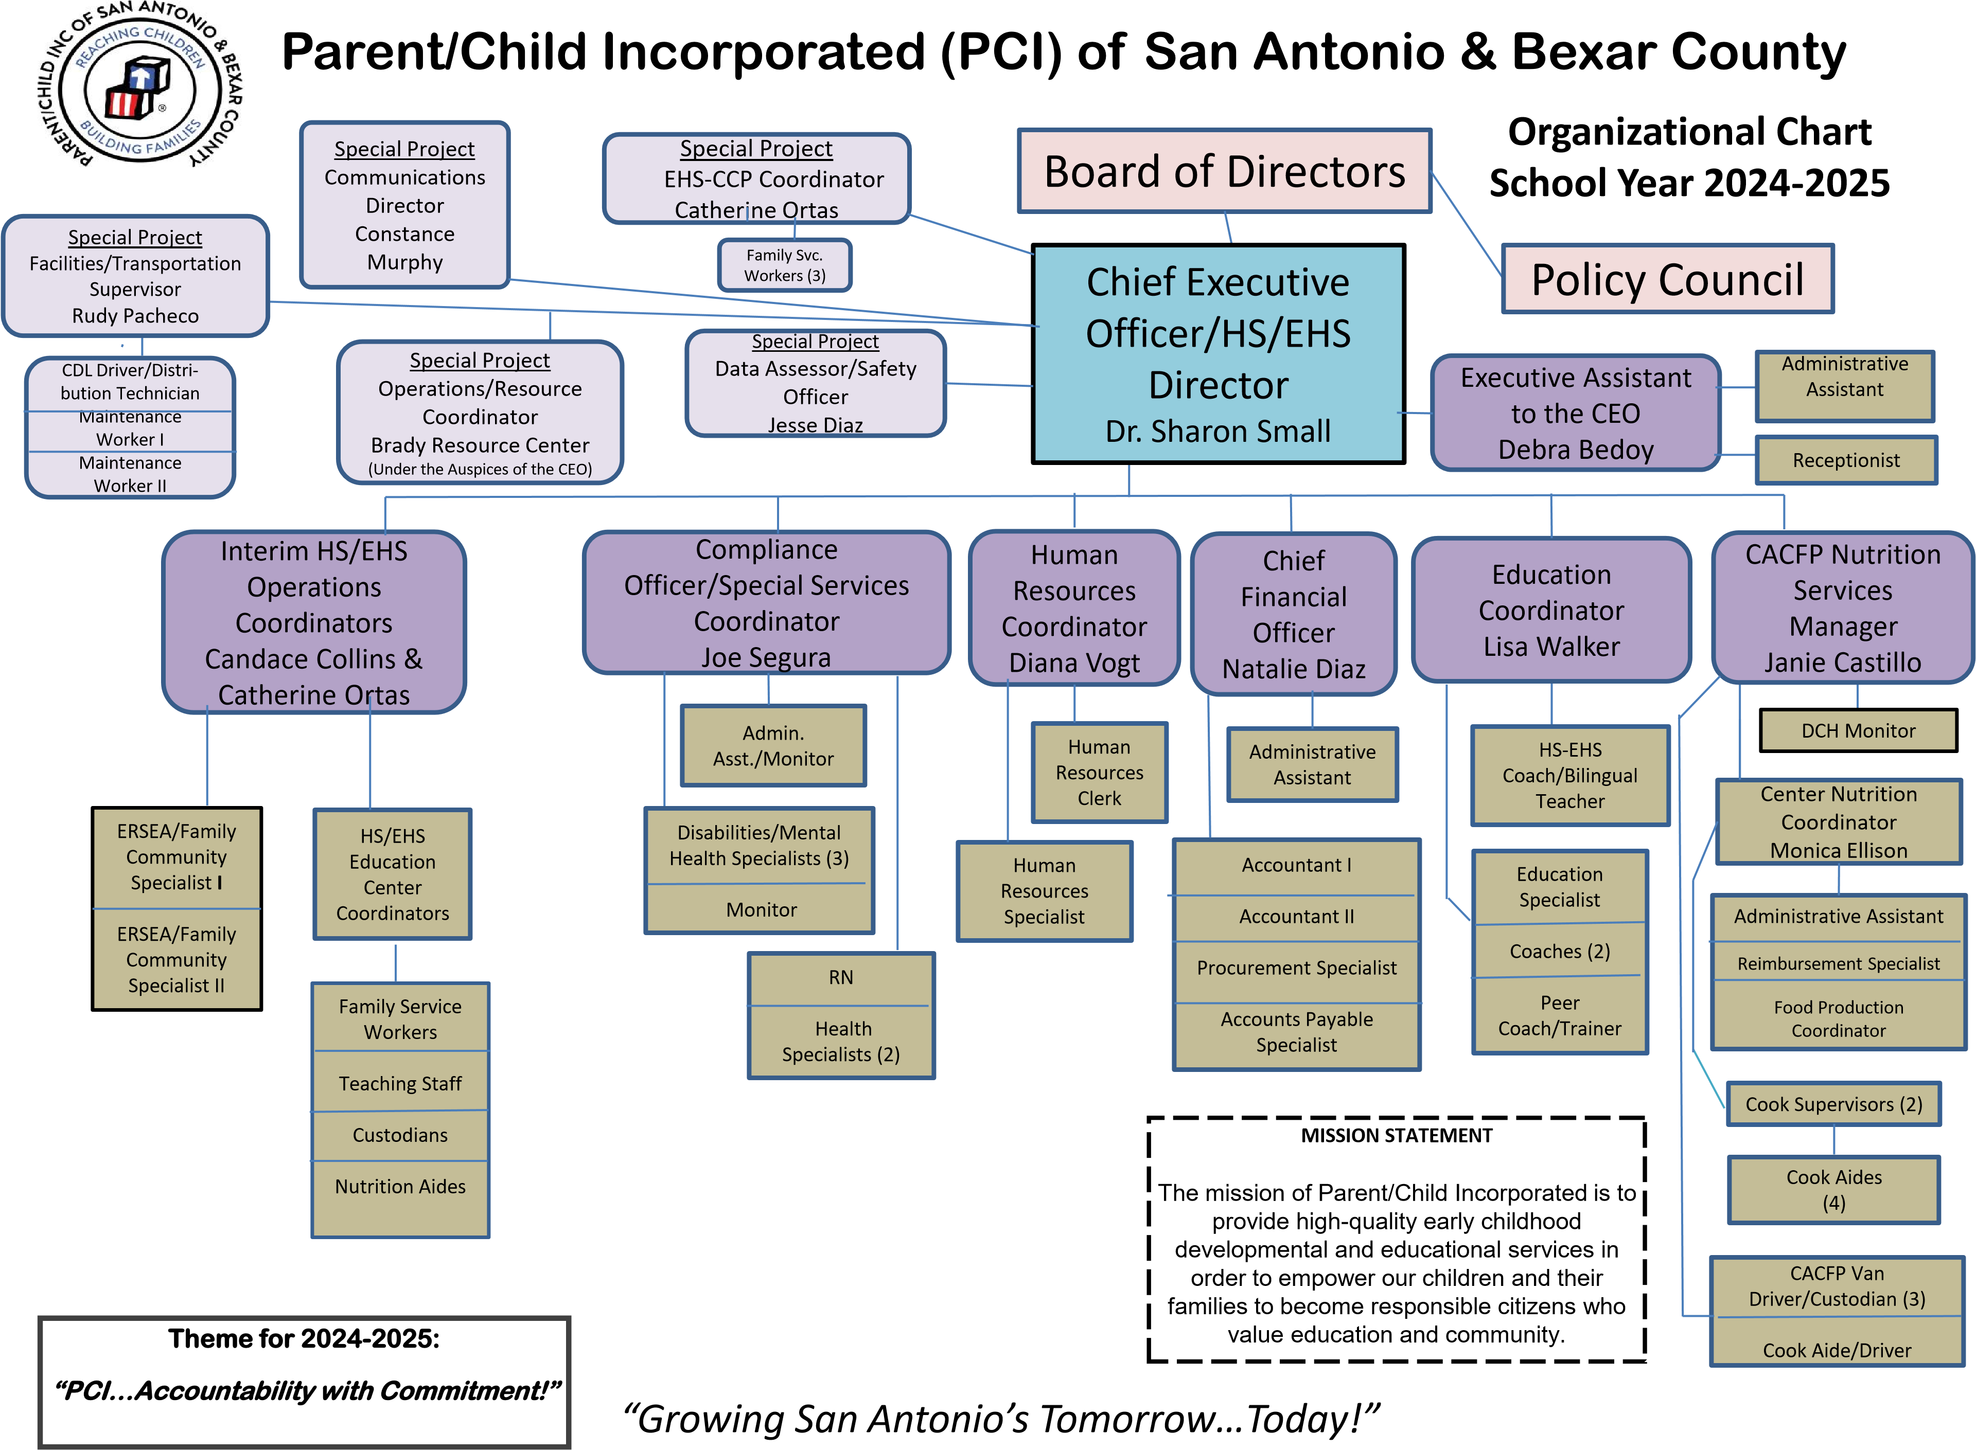

NOTES
______________________________________________________________________________________________________________________________________________________________________________________________________________________________________________________________________________________________________________________________________________________________________________________________________________________________________________________________________________________________________________________________________________________________________________________________________________________________________________________________________________________________________________________________________________________________________________________________________________________________________________________________________________________________________________________________________________________________________________________________________________________________________________________________________________________________________________________________________________________________________________________________________________________________________________________________________________________________________________________________________________________________________________________________________________________________________________________________________________________________________________________________________________________________________________
PARENT/CHILD INCORPORATED
CHILD AND ADULT CARE FOOD PROGRAM PARTNERSHIP
Dear Parent/Guardian:
This letter is intended for parents or guardians of children enrolled in a childcare center. This center offers healthy meals to all enrolled children as part of our participation in the U.S. Department of Agriculture’s (USDA) Child and Adult Care Food Program (CACFP). The CACFP provides reimbursements for healthy meals and snacks served to children enrolled in childcare. Please help us comply with the requirements of the CACFP by completing the attached Meal Benefit Income Eligibility Form. In addition, by filling out this form, we will be able to determine if your child(ren) qualifies for free or reduced-price meals.
1. Do I need to fill out a Meal Benefit Form for each of my children in day care? You may complete and submit one CACFP Meal Benefit Income Eligibility Form for all children enrolled in childcare in your household only if the children in childcare are enrolled in the same center. We cannot approve a form that is not complete, so be sure to read the instructions carefully and fill out all required information. Return the completed form to the center director.
2. Who can get free meals without providing income information? Children in households getting Supplemental Nutrition Assistance Program (SNAP) (formerly Food Stamps), Temporary Assistance for Needy Families (TANF), or Food Distribution Program on Indian Reservations (FDPIR) can get free meals. Foster children (reference question #8 for more information on foster children) and children enrolled in a Head Start Program (HSP), Early Head Start Program (EHSP), or Even Start Program (ESP) and have not entered kindergarten) are also eligible for free meals. Households with children enrolled in an HSP, EHSP or ESP can provide a certification letter from the program of the child’s enrollment and do not need to complete the CACFP Meal Benefit Income Eligibility Form.
3. Who can get reduced price meals? Your children can get low-cost meals if your household income is within the reduced-price limits on the Income Chart, sent with this application. Children in households participating in WIC may be eligible for reduced price meals.
4. May I fill out a form if someone in my household is not a U.S. citizen? Yes. You or your children do not have to be U.S. citizens to qualify for meal benefits offered at the childcare center.
5. Who should I include as members of my household? You must include everyone in your household (such as grandparents, other relatives, or friends who live with you) who shares income and expenses. You must include yourself and all the children who live with you. You also may include foster children who live with you.
6. How do I report income information and changes in employment status? The income you report must be the total gross income listed by source for each household member received last month. If last month’s income does not accurately reflect your circumstances, you may provide a projection of your monthly income. If no significant change has occurred, you may use last month’s income as a basis to make this projection. If your household’s income is equal to or less than the amounts indicated for your household’s size on the attached Income Chart, the center will receive a higher level of reimbursement. Once properly approved for free or reduced-price benefits, whether through income or by providing a current SNAP, TANF, FDPIR case number, you will remain eligible for those benefits for 12 months. You should notify us, however, if you or someone in your household becomes unemployed and the loss of income causes your household income to be within the eligibility standards.
7. What if my income is not always the same? List the amount that you normally get. For example, if you normally get $1000 each month, but you missed some work last month and only got $900, put down that you get $1000 per month. If you normally get overtime, include it, but not if you only get it sometimes.
8. What if I have foster children? Foster children that are under the legal responsibility of a foster care agency or court are eligible for free meals. Any foster child in the household is eligible for free meals regardless of income. Households may include foster children on the Meal Benefit Form but are not required to include payments received for the foster child as income. Households wishing to apply for such benefits for foster children can provide the Texas Department of Family and Protective Services Form 2085FC, Placement Authorization Foster Care/Residential Care, to their child’s caregiver and do not need to complete the CACFP Meal Benefit Income Eligibility Form.
9. We are in the military; do we include our housing and supplemental allowances as income? If your housing is part of the Military Housing Privatization Initiative and you receive the Family Subsistence Supplemental Allowance, do not include these allowances as income. Also, in regard to deployed service members, only that portion of a deployed service member’s income made available by them or on their behalf to the household will be counted as income to the household. Combat Pay, including Deployment Extension Incentive Pay (DEIP) is also excluded and will not be counted as income to the household. All other allowances must be included in your gross income.
In the operation of child feeding programs, no person will be discriminated against because of race, color, national origin, sex, age or disability.
If you have other questions or need help, call PCI Nutrition Services, at 210-226-6232.

Sincerely,
Nutrition Services Manager CACFP Meal Benefit Income Eligibility

Instructions - Income Eligibility Guidelines for Determining Free and Reduced-Price Benefits (H1625-A)

Contracting entities, sites and/or Day Care Home providers must give this form to Program participants annually and potential participants as needed. This form must be provided at the same time as the CACFP Meal Benefit Income Eligibility form, and as requested.

Form Retention

Keep Form H1625-A for three years from the end of the program year. Exception: If audit findings, claims or litigation have not been resolved by the end of the retention period, all forms and records must be retained until all issues are resolved.

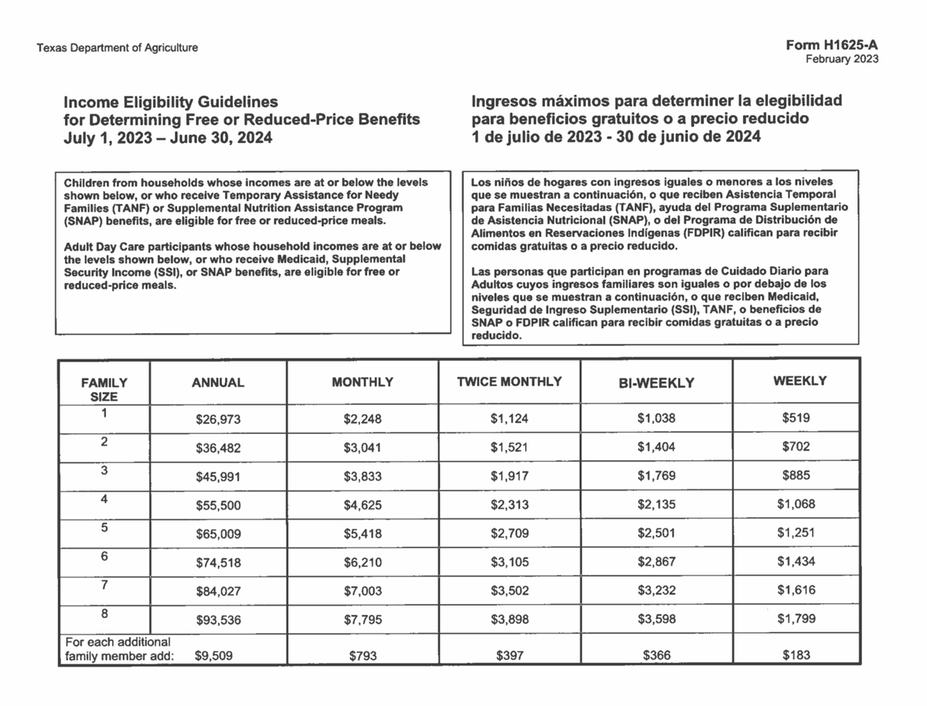

Start now with WIC
To become a WIC Client, start your application online or find a WIC office near you to schedule an appointment.
WIC Clients are:
- Pregnant women
- Breastfeeding women
- Infants
- Families with children younger than 5 years old

As a WIC Client, you will get:
Healthy food
Breastfeeding support
One-on-one counseling with nutritionists
Recipes & cooking demonstrations
Nutrition classes

Texas WIC Income Guidelines
WIC is open to many incomes and families. If you are on Medicaid, TANF, or SNAP you meet the income eligibility guidelines for WIC. If you do not qualify for these programs, you may still qualify for WIC by meeting the income guidelines for your household.
Number of Household Members* | Gross Monthly Household Income**
1 | $0 up to $2,322
2 | $0 up to $3,152
3 | $0 up to $3,981
4 | $0 up to $4,810
5 | $0 up to $5,640
6 | $0 up to $6,469

*A pregnant woman’s household is increased by the number of infants she is expecting. For more than six household members, or if you have any income questions, call your local WIC clinic.
** Income can also be determined on a weekly or biweekly basis.

There are 3 options to start your application:
- Call 800-942-3678. We will ask you a few questions and see if you qualify. If you are eligible, we will connect you with a WIC office to schedule an appointment.
- Find a WIC office near you and call to schedule an appointment.
- Start your application online. It takes only a few minutes. After you submit your application, someone from a WIC office will contact you to see if you qualify and schedule an appointment.

